**Final Year Project Report**

**Smart Together**



**Project Advisor:**

**Noaman Saleem**

**Submitted By:**

**Bilal Tariq: F2019065106**

**Muhammad Waleed Khan: F2019065177**

**Muhammad Umar Farooq: F2019065193**

**Sillah Cheema: F2019065062**

**Session**

**F2022**

**University of Management and Technology**

**C-II Johar Town Lahore Pakistan**

**Dedication**

First and foremost, we offer this project's dedication to ALLAH ALMIGHTY, as without His compassion and mercy, we would not have been able to complete it within the given time frame. It is through His strength that we accomplished this endeavor. Next, we extend our heartfelt gratitude to our beloved parents for their unwavering support and blessings.

Our parents have taught us the value of seeking knowledge for its own sake and we dedicate this project to them. Additionally, we extend our dedication to our supportive friends who have been by our side throughout the journey. Their unwavering support and encouragement empowered us and made this project possible. We are forever thankful for everything they have done for us.

This project is also dedicated to our teachers, who imparted in us the lesson that even most significant task can be achieved by taking one step at a time. Their guidance and teachings have been invaluable. Lastly, we express our gratitude to our supervisor, whose thorough assistance played a vital role in completion of this task.

## 

**Final Approval**

* **Head of Department**  ______________________

Department of Informatics & Systems

School of Systems & Technology

UMT Lahore

* **Director (Final Year Projects-CS)** ______________________

Department of Computer Science.

School of Systems & Technology

UMT Lahore

* **Supervisor** ______________________
* Department of Informatics & Systems.
* School of Systems & Technology

UMT Lahore

* **Co-Supervisor** ______________________

**Acknowledgment**

Our special admiration should be given to our teacher equally to our Dean who gave us this opportunity to do this joyful venture in this matter, which also helped us to get connected with latest research. We also thank chairperson department of informatics. We also recognize project directors of the last year. Also, maybe we need to praise our community and educators who guide us a lot in completing this task in limited time and for being a bit challenging. We take this opportunity to suppress our altruistic assessment of every individual who has fed us to the extent of this Capstone event. It would not have been possible without the guidance and enlightenment of many people. So we praise their commitment and we appreciate them a lot from our side.

**Project Title: Smart Together**

**Objective:**

Objectives of this project are to provide a platform to students to get their educational needs fulfilled, provide an earning platform to teachers where they can sell their services. Offer counselling services to students who need and provide all educational updates. This system will offer end-to-encrypted meeting, users will be able to do chat, leave feedback. People will be also volunteering their services through this platform

**Undertaken by :**

**Bilal Tariq: F2019065106**

**Muhammad Waleed Khan: F2019065177**

**Muhammad Umar Farooq: F2019065193**

**Sillah Cheema: F2019065062**

**Supervised by: Noaman Saleem**

**Starting Date**

**F2022**

**Completion Date**

**S2023**

**Tools Used**

•      React js

•      Flutter

•      Node js

•      Express js

•      Bootstrap 4.0+

•      Material UI

•      MongoDB/ Firebase (Optional)

**Operating System:**

Windows

**Plagairism ReportAbstract**

Existing traditional system based on finding tutors for students is a very time consuming and tiring process for students. Also, for teachers who want to sell their services to make earning, this is so difficult and find students who need such services.

Over the years now students are more willing to access online services for their educational needs. Most of the students need extra help in the daily educational tasks some also require a full-time tutor who can help them in their studies. So, this system will help such students, they would be able to get their educational tasks done easily from the ease of their homes. Secondly, people who are willing to sell, this system will be helpful for them all whether it is providing home tutoring services, selling helpful study materials, offering counselling services or teaching particular course in part time.

Revision Chart

| Version | Primary Author(s) | Description of Version | Date Completed |
| --- | --- | --- | --- |
| Draft | 04-11-2022 | Initial draft created for distribution and review comments | 05-12-2022 |
| Preliminary | 07-12-2022 | Second draft incorporating initial review comments, distributed for final review | 01-01-2023 |
| Final | 03-01-2023 | First complete draft, which is placed under change control | 20-01-2023 |
| Revision 1 | 02-02-2023 | Revised draft, revised according to change control process and maintained under change control | 02-03-2023 |
| Revision 2 | 03-03-2023 | Revised draft, revised according to change control process and maintained under change control | 04-05-2023 |
| Etc. | TBD | TBD | TBD |

# Contents

Table of Contents

Contents 1

1. Introduction 3

1.1 Motivations 3

1.2 Project Overview 3

1.3 Problem Statement 3

1.4 Objectives 4

1.5 Scope 4

2. Domain Analysis 5

2.1 Customer 5

2.2 Stakeholders 5

2.3 Affected Groups with social or economic impact 5

2.4 Dependencies/ External Systems 5

2.5 Reference Documents 6

2.5.1 Feature Comparison 6

2.5.2 Related Projects 6

3. Requirements analysis 8

3.1 Requirements 8

3.1.1 Functional requirements: 8

3.1.2 Non-Functional requirements: 10

3.2 List of Actors 10

3.3 List of use cases 11

3.4 USE CASE diagram 12

3.5 Extended use cases 13

3.6 Mock Screens 34

3.6.1 Prototype1: Sign up 34

3.6.2 Prototype2: (P2) Sign-in 34

3.6.3 Prototype3: (P3) Courses Page 35

3.6.4 Prototype4: (P4) Home Page 35

3.6.5 Prototype5: (P5) About Page 36

4. DFD 37

4.1 DFD Level 0 37

4.2 DFD Level 1 38

5. DESIGN OF SYSTEM 39

5.1 SAD 39

5.2 Class Diagram 40

5.3 Sequences 41

5.3.1 Sign up 41

5.3.2 Sign-in 41

5.3.3 Change Password 42

5.3.4 Publish News 42

5.3.5 Email Verification 43

5.3.6 Give Feedbacks 43

5.3.7 Logout 44

5.4 ERD 45

5.5 Collaboration Diagram 46

6. Development Setup 47

1.1 A well-known programming climate can be utilized for building high scale applications that requirements to help different simultaneous solicitations. 47

1.2 Deployment setup 47

1.2.1 Restrictions 48

7. Testing 49

7.1 Extended Test Cases 49

7.2 Decision Table 108

7.2.1 Decision coverage table 108

8. RESULTS/OUTPUTS/STATICS 111

8.1 %completion 111

8.2 %accuracy 111

8.3 %correctness 111

9. CONCLUSION 112

10. FUTURE WORK 113

11. BIBLIOGRAPHY 114

11.1 Other References 114

12. APPENDIX 115

12.1 Glossary of terms 115

12.2 Pre-requisites 115

## 

# Introduction

We are creating a web-based portal that allows tutor and students to get connected to each other. Tutors can sell their services here and students can get benefited from here.

## Motivations

Basic motivation for creating this system is help students to find tutors for their educational needs and to tutors, provide a platform through which they can find students for teaching and make earning. Also, students who come from remote areas and are not familiar to the practices of big cities, they can find them educational counsellors and home tutors in their respective area according to their budget.

## Project Overview

Existing manual system based on finding tutors for students is a very time consuming and tiring process for students. Also, for teachers who want to sell their services to make earning, this is so difficult and find students who need such services.

Most of students need extra help in their daily educational tasks some also require a full-time tutor who can help them in their studies. So, this system will help such students, they would be able to get their educational tasks done easily from ease at their homes. Secondly, for people who are willing to sell, this system will be helpful for them all whether it is providing home tutoring services, selling helpful study materials, offering counselling services or teaching particular course as part time.

## Problem Statement

With advancement of new innovations, there is no question that web-based instructive stages have supplanted customary approaches to learning. From distinguishing standard study hall issues to collaborating with educators, learning through tests and games to doing home assignments on the web, instruction applications have changed understudies concentrating on propensities. It requires a ton of exertion for understudies to find coaches for themselves physically or getting their instructive issues tackled. Thus, we propose to make this mentoring application, where guide and understudies can without much of a stretch find what they are wanting, where can both can persuade their concerns to be settled.

## Objectives

This project will be an effort to provide a platform for students to get their educational needs fulfilled, provide an earning platform to teachers where they can sell their services. Offer counselling services to students who need and provide all educational updates. This system will offer end-to-encrypted meeting, users will be able to do chat, leave feedback. People will be also volunteering their services through this platform.

## Scope

We are bridging the students who need help in their studies and tutors who need students to teach where they can select tutor of their own choice and prefer the learning mode as well. The students would also be able to find counsellors for their career counselling who will assist them according to their interests. There will be whole category for test preparations. Students can also find educational notes from experts through this portal. This app will be used in any place where students and teachers exist. Our main target is to provide job opportunity to people who want to earn by teaching and provide a platform to students to fulfill all their educational needs.

# Domain Analysis

## Customer

* Student
* Tutor

## Stakeholders

|  |  |
| --- | --- |
| **Stakeholder** | **Role in System** |
| Student | Students will actually want to join and track down guide. Students can pick guide of his decision and leave an input. Students can seek help as well as notes from specialists. Coaches can likewise be employed for limited capacity to focus time or for a particular theme's figuring out in low spending plan. Understudy will have the option to do visits and get news refreshes. |
| Tutor | Tutor will have the option to track down students, give tutoring(Home or on the web), profession directing, sell notes, acknowledge demands from understudies. |
| Online Portal | This portal will connect students with tutors as simple as sellers with buyers. The portal will send relevant news updates to relevant people as well as manage the whole feedback from users. |

## Affected Groups with social or economic impact

**Students:**

Students can find their required services through this platform.

**Tutors:**

Tutors can find students to offer tutoring services, counselling services and helping notes.

## Dependencies/ External Systems

* Web browser e.g. chrome, Firefox and internet explorer.
* Internet connection
* External Bank Entity

## Reference Documents

### Feature Comparison

1. Khan academy
2. Udemy
3. TutorBees.net
4. Teacheron.com
5. Sabak.pk

### Related Projects

1. **TeacherOn.com:**

TeacherOn.com is a free site, trusted by large number of understudies and instructors, from one side of the planet to the other. You can track down neighborhood mentors, online educators, and instructors to assist with coaching, training, tasks, scholarly ventures, and papers for north of 9500 subjects.

1. **Tutorbees.net:**

Whether an understudy or an educator, the gateway gives a consistent encounter, with master mentors offering timing adaptability in reasonable charge bundles. It is a straightforward three-step process where you sign in, select the reasonable subject master and take a free demo from the guide. Once fulfilled, you can choose the cost straightforwardly with your mentor. Our master guides are ever-prepared to instruct and show understudies online with an understudy driven educating approach. For quality confirmation and understudy's comfort, every one of our classes are auto-recorded and can be seen later. Furthermore, our understudies sign up for different subjects as a result of their extraordinary internet growth opportunity.

1. **Khan academy**

Khan Foundation is non-benefit instructive association made in 2008 by Sal Khan. It aims to make a bunch of online instruments that assist with teaching understudies. Association delivers short illustrations as recordings. Its site additionally incorporates advantageous practice activities and materials for teachers and instructors. It has created more than 8,000 video illustrations showing a wide range of scholarly subjects, initially zeroing in on math and sciences. All assets are accessible for nothing to clients of site and application.

1. **Udemy**

“Udemy” is schooling innovation organization that gives an internet learning and educating stage. It was established in May 2010. “Udemy” is a main worldwide commercial center for instructing and picking up, interfacing a great many understudies to abilities they need to succeed. As obviously enlistments November 2022, educators showing courses in north of 75 dialects. Understudies take courses fundamentally to further develop work related abilities. A few courses create credit toward specialized confirmation. It draws in corporate mentors looking to make coursework for workers of their organization.

1. **Sabak.pk**

Its principal objective is to make top notch mentoring recordings for all Pakistani understudies concentrating on in both English medium and Urdu medium schools. Furthermore, Sabaq Establishment conveys these video addresses on the web, totally liberated from cost.

Sabaq Light is a disconnected duplicate of Sabaq.pk recordings and practice tests planned for schools and requires no Web association with work. This permits schools all over Pakistan including distant regions to profit from Sabaq.pk and further develop their understudy learning in the study hall and PC lab, and furthermore further develop their educator abilities through ceaseless educator preparing.

# Requirements analysis

## Requirements

### Functional requirements:

#### Student

FR-1: The student will have the capability to login into system by providing correct username and password.

FR-2: The student shall be able to send request to tutor.

FR-3: The student could be able to buy notes.

FR-4: The student shall be able to take counselling appointment from the tutor.

FR-5: The student will be able to give feedback to the tutors.

FR-6: The student can give rating to his/her tutor.

FR-7: The understudy will have the option to send demand for markdown in the expense.

FR-8: The understudy will have the option to do visit with some other understudy and with his/her guide.

FR-9: The student could be able to set schedule of his classes.

FR-10: The student will have the ability to edit his/her profile.

FR-11: The student shall be able to view the list of available tutor.

FR-12: The student can see the updated newsfeed by the admin.

FR-13: The understudy will have the option to logout his record.

#### Tutor

FR-14: The tutor shall be able to login into system by providing correct username and password.

FR-15: The mentor will have the option to acknowledge/drop the solicitation for coaching.

FR-16: The tutor can sell notes.

FR-17: The tutor will have the capability to assign tasks to the students.

FR-18: The tutor shall be able to set deadline for the task.

FR-19: The guide will have the option to change the cutoff time for the undertaking.

FR-20: The tutor shall be able to assign grades.

FR-21: The coach will have the option to do visit with understudies.

FR-22: The mentor will have the option to deal with his/her classes plan.

FR-23: The tutor could post his/her available timing slots.

FR-24: The tutor would updated newsfeed by the admin.

FR-25: The coach shall be able to his/her rating given by the students.

FR-26: The Guide shall be able to provide counselling to the students.

FR-27: The coach will have the option to see understudy profile.

FR-28: The tutor will have the capability to logout his/her account.

#### Admin

FR-29: The admin shall be able to login in system as a super admin.

FR-30: The administrator will have the option to refresh understudy data.

FR-31: The admin could update tutor information.

FR-32: The admin shall be able to publish news.

FR-33: The administrator will have the option to acknowledge/drop expense rebate demand by the understudy.

FR-34: The admin can upload documents for eligible criteria.

FR-35: The admin shall be able to remove student/tutor from the system.

FR-36: The administrator will have the option to impede understudy/mentor from the framework.

FR-37: The admin will have the access to manage schedule for student/tutor.

FR-38: The admin shall be able to view student profile.

FR-39: The admin can view tutor profile.

### Non-Functional requirements:

NFR-1: The system shall be able to confirm whether the user is using a registered

number or not.

NFR-2: The system will collaborate with other software’s for transactions

NFR-3: The system will have the option to send message to guide when any understudy demand come.

NFR-4: The system shall be able to send email for instructions if the user is new.

NFR-5: The user should be accomplished with minimum steps, and in easy way.

NFR-6: The Presentation of the system can be quick and precise.

NFR-7: The System should handle expected and unexpected errors.

NFR-8: The user should be allowed to use application after authentication and

verification.

NFR-9:  The user shall be able to use correct Username and Password to login in

system.

NFR-10: Only the registered users will be allowed for login in system.

NFR-11: The system shall be available for its valid users 24/7.

## List of Actors

1. Student
2. Tutor
3. Admin

## List of use cases

1. Sign-Up
2. Sign-in
3. Manage profile
4. Chat
5. Sign-out
6. Manage transactions
7. Publish news
8. Manage feedback
9. Need notes from experts
10. See Tutor details
11. Search Tutor
12. Submit dues
13. View Results
14. Give feedback
15. Post tuition
16. See student details
17. Get payments
18. Check Feedback
19. Post Results
20. Get news updates
21. Manage offers/Requests

## USE CASE diagram

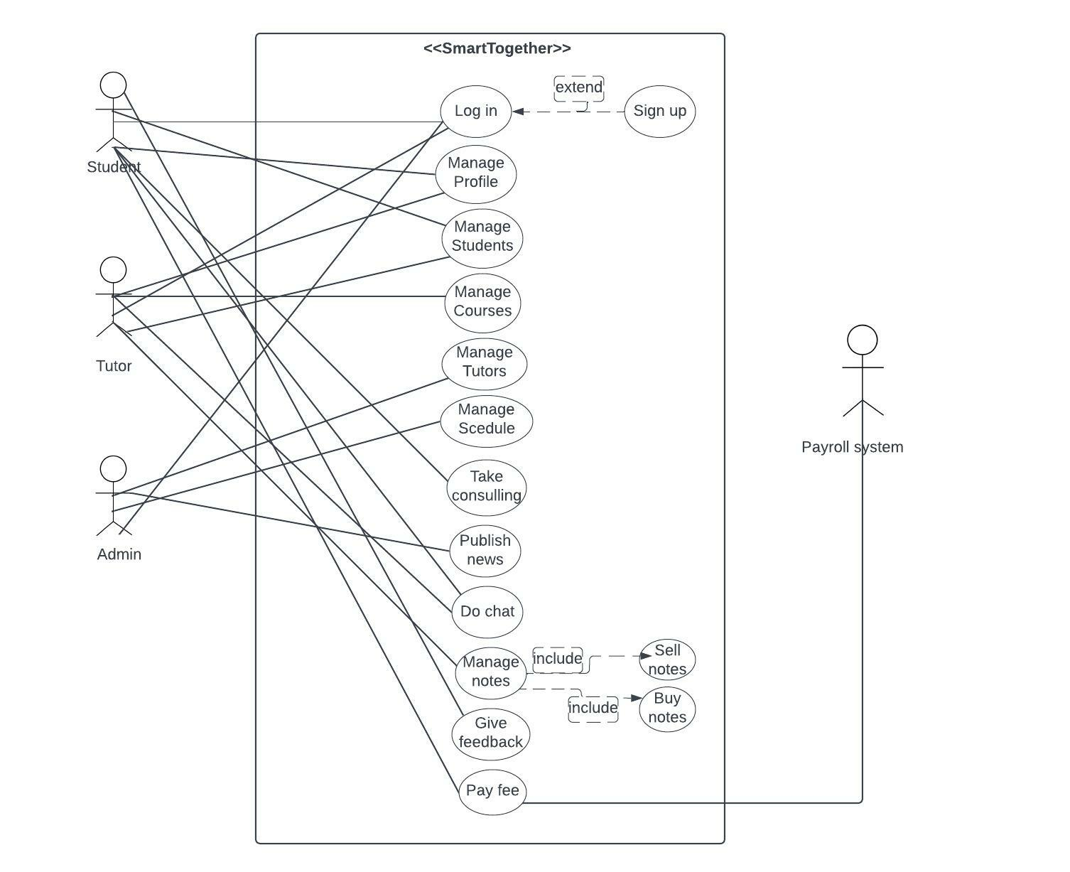

USE CASE

## Extended use cases

|  |  |  |  |  |
| --- | --- | --- | --- | --- |
| **ID:** | **UC-1** | | | |
| **Name:** | **Sign-Up** | | | |
| **Made By:** | **Bilal Tariq** | | **Renewed By:** | **Bilal Tariq** |
| **Created on:** | **15-01-2023** | | **Renewed on:** | **20-06-2023** |
| **Users:** | | Tutor/ Student | | |
| **Depiction:** | | The user chooses sign up. | | |
| **Trigger:** | | When user wants to register into portal. | | |
| **Preconditions:** | | * Enter credentials | | |
| **Post conditions:** | | * If sign up is successful | | |
| **Normal Flow:** | | * Choose sign up method * Fill the data into fields * Click the login page * Go to the home page | | |
| **Other flow** | | * Data empty * Error | | |
| **Exceptions:** | | If user was restricted | | |
| **Includes:** | | Data to be entered in correct and relevant field. | | |
| **Frequency of**  **Use:** | | On demand | | |
| **Special**  **Requirements:** | | User has valid email and phone. | | |
| **Assumptions:** | | User is literate to English and understands the interface. | | |
| **Problems:** | | Null | | |

|  |  |  |  |  |
| --- | --- | --- | --- | --- |
| **ID:** | **UC-2** | | | |
| **Name:** | **Sign-in** | | | |
| **Made By:** | **Bilal Tariq** | | **Made By:** | **Bilal Tariq** |
| **Created on:** | **15-01-2023** | | **Created on:** | **15-01-2023** |
| **Users:** | | Tutor/ Student | | |
| **Description:** | | The user chooses sign in. | | |
| **Trigger:** | | When user wants to sign in-into portal. | | |
| **Preconditions:** | | * Signed-up | | |
| **Post conditions:** | | * If successful * If page loaded | | |
| **Normal Flow:** | | * Go login * Fill data * Go login button * Go to home page | | |
| **Other flow:** | | * Didn’t choose * Data empty * Error | | |
| **Exceptions:** | | If user is restricted. | | |
| **Includes:** | | data is valid. | | |
| **Frequency of**  **Use:** | | demand. | | |
| **Special**  **Requirements:** | | User email and phone is verified. | | |
| **Assumptions:** | | User knows login id and password. | | |
| **Notes and**  **Issues:** | | Null. | | |

|  |  |  |  |  |
| --- | --- | --- | --- | --- |
| **ID:** | **UC-3** | | | |
| **Name:** | **Manage profile:** | | | |
| **Made By:** | **Bilal Tariq** | | **Made By:** | **Bilal Tariq** |
| **Created on:** | **15-01-2023** | | **Created on:** | **15-01-2023** |
| **Users:** | | Tutor/ Student | | |
| **Description:** | | The user chooses to edit profile. | | |
| **Trigger:** | | When user wants to manage his profile. | | |
| **Preconditions:** | | * If successful * If page loaded | | |
| **Post conditions:** | | * Go login * Fill data * Go login button * Go to home page | | |
| **Normal Flow:** | | * Didn’t choose * Data empty * Error | | |
| **Other flow:** | | * If successful * If page loaded | | |
| **Exceptions:** | | If profile was under observation | | |
| **Includes:** | | User ensures correct data to updated. | | |
| **Frequency of**  **Use:** | | On demand. | | |
| **Special**  **Requirements:** | | User enters relevant data. | | |
| **Assumptions:** | | **User understand that it can take some longer to update details.** | | |
| **Notes and**  **Issues:** | | **Null.** | | |

|  |  |  |  |  |
| --- | --- | --- | --- | --- |
| **ID:** | **UC-4** | | | |
| **Name:** | **Chat** | | | |
| **Made By:** | **Bilal Tariq** | | **Made By:** | **Bilal Tariq** |
| **Created on:** | **15-01-2023** | | **Created on:** | **15-01-2023** |
| **Users:** | | Tutor/ Student | | |
| **Description:** | | The user chooses to chat with other user. | | |
| **Trigger:** | | When user wants to chat with other users. | | |
| **Preconditions:** | | * If successful * If page loaded | | |
| **Post conditions:** | | * Go login * Fill data * Go login button * Go to home page | | |
| **Normal Flow:** | | * Didn’t choose * Data empty * Error | | |
| **Other flow:** | | * If successful * If page loaded | | |
| **Exceptions:** | | If user was blocked. | | |
| **Includes:** | | Avoiding inappropriate messages. | | |
| **Frequency of**  **Use:** | | On demand. | | |
| **Special**  **Requirements:** | | Both users willing to chat. | | |
| **Assumptions:** | | Users understands messaging system. | | |
| **Notes and**  **Issues:** | | Null. | | |

|  |  |  |  |  |
| --- | --- | --- | --- | --- |
| **ID:** | | UC-5 | | |
| **Name:** | | Sign-out | | |
| **Made By:** | **Bilal Tariq** | | **Renewed By:** | **Bilal Tariq** | |
| **Created on:** | **15-01-2023** | | **Renewed on:** | **20-06-2023** | |
| **Users:** | | Tutor/ Student | | | |
| **Actors:** | | Tutor/ Student | | |
| **Description:** | | The user chooses to sign-out his account. | | |
| **Trigger:** | | When user wants to sign-out. | | |
| **Preconditions:** | | * Choose home page * Click the sign out button | | |
| **Post conditions:** | | * Null | | |
| **Normal Flow:** | | * Choose profile * Click the chat button * Send the message | | |
| **Other flow:** | | * Didn’t choose home page * Connection error | | |
| **Exceptions:** | | Null | | |
| **Includes:** | | Null. | | |
| **Frequency of**  **Use:** | | 50 per hour. | | |
| **Special**  **Requirements:** | | Null. | | |
| **Assumptions:** | | **User understands signing out.** | | |
| **Notes and**  **Issues:** | | **Null.** | | |

|  |  |  |  |  |
| --- | --- | --- | --- | --- |
| **ID:** | **UC-6** | | | |
| **Name:** | Manage transactions | | | |
| **Made By:** | **Bilal Tariq** | | **Made By:** | **Bilal Tariq** |
| **Created on:** | **15-01-2023** | | **Created on:** | **15-01-2023** |
| **Users:** | | Admin | | |
| **Description:** | | The admin will manage transactions between tutors and students. | | |
| **Trigger:** | | When dues are not cleared by the student or tutor reports some issue regarding dues. | | |
| **Preconditions:** | | Sign-in | | |
| **Post conditions:** | | * If log in successful * If manage payments page is loaded | | |
| **Normal Flow:** | | * Click manage payments * Check the credentials * Click the dues are clear or not button * Take to the home page | | |
| **Other flow:** | | * Didn’t choose home page * Connection error | | |
| **Exceptions:** | | If dues are not clear, the student account will be notified and then blocked.  If dues are clear the status would be updated. | | |
| **Includes:** | | Managing and ensuring valid transactions. | | |
| **Frequency of**  **Use:** | | On demand. | | |
| **Special**  **Requirements:** | | **Valid credentials to be provided as proof.** | | |
| **Assumptions:** | | **User understands privacy policy.** | | |
| **Notes and**  **Issues:** | | **Null.** | | |

|  |  |  |  |  |
| --- | --- | --- | --- | --- |
| **ID:** | **UC-7** | | | |
| **Name:** | Publish news | | | |
| **Made By:** | **Bilal Tariq** | | **Made By:** | **Bilal Tariq** |
| **Created on:** | **15-01-2023** | | **Created on:** | **15-01-2023** |
| **Users:** | | Admin | | |
| **Description:** | | The admin will publish the news to subscribed users. | | |
| **Trigger:** | | When admin chooses to publish news. | | |
| **Preconditions:** | | Sign-in | | |
| **Post conditions:** | | * If log in successful * If news update is loaded * If news post the news was clicked | | |
| **Normal Flow:** | | * Choose publish news page * Enter the news update * Choose to whom the news should be published(tutor/Student/all) * Take to the home page | | |
| **Other flow:** | | * Didn’t choose publish news page * Data field is empty * No audience is selected * Connection error | | |
| **Exceptions:** | | If news updates is not enabled, the news will not be sent to such users. | | |
| **Includes:** | | Delivering news to only relevant user. | | |
| **Frequency of**  **Use:** | | As per usage. | | |
| **Special**  **Requirements:** | | Only valid news to be published. | | |
| **Assumptions:** | | Understanding news and updates policy. | | |
| **Notes and**  **Issues:** | | Null. | | |

|  |  |  |  |  |
| --- | --- | --- | --- | --- |
| **ID:** | **UC-8** | | | |
| **Name:** | Manage feedback | | | |
| **Made By:** | **Bilal Tariq** | | **Made By:** | **Bilal Tariq** |
| **Created on:** | **15-01-2023** | | **Created on:** | **15-01-2023** |
| **Users:** | | Admin | | |
| **Description:** | | The admin will manage the feedback given by students. | | |
| **Trigger:** | | When student chooses to post feedback for particular tutor. | | |
| **Preconditions:** | | Sign-in   * Check whether student has studies from specific tutor that he is going to give feedback about. | | |
| **Post conditions:** | | * Null | | |
| **Normal Flow:** | | * Choose manage feedback * Check feedback * Click the post feedback button | | |
| **Other flow:** | | * Didn’t choose manage feedback page * Feedback list is empty * No pending feedback * Connection error | | |
| **Exceptions:** | | If student has not already studies at least 1 course from specific tutor, the feedback will not be posted. | | |
| **Includes:** | | Allowing only valid feedback. | | |
| **Frequency of**  **Use:** | | demand. | | |
| **Special**  **Requirements:** | | Feedback to be posted by only active users. | | |
| **Assumptions:** | | User understands feedback terms. | | |
| **Notes and**  **Issues:** | | Will be changed in future. | | |

|  |  |  |  |  |
| --- | --- | --- | --- | --- |
| **ID:** | **UC-9** | | | |
| **Name:** | Need notes from experts | | | |
| **Made By:** | **Bilal Tariq** | | **Made By:** | **Bilal Tariq** |
| **Created on:** | **15-01-2023** | | **Created on:** | **15-01-2023** |
| **Users:** | | Student | | |
| **Description:** | | The student will search for notes. | | |
| **Trigger:** | | When student chooses to post feedback for particular tutor. | | |
| **Preconditions:** | | Sign-in | | |
| **Post conditions:** | | * Null | | |
| **Normal Flow:** | | * Search for notes * Click on the post | | |
| **Other flow:** | | * Didn’t enter correct details of desired notes * Didn’t click on the post | | |
| **Exceptions:** | | If no relevant offers are available, search page will say ‘No Results found’. | | |
| **Includes:** | | Searching part time tutors as well. | | |
| **Frequency of**  **Use:** | | High | | |
| **Special**  **Requirements:** | | Nothing. | | |
| **Assumptions:** | | User understands search interface. | | |
| **Notes and**  **Issues:** | | Can be changeable | | |

|  |  |  |  |  |
| --- | --- | --- | --- | --- |
| **ID:** | **UC-10** | | | |
| **Name:** | See Tutor details | | | |
| **Made By:** | **Bilal Tariq** | | **Made By:** | **Bilal Tariq** |
| **Created on:** | **15-01-2023** | | **Created on:** | **15-01-2023** |
| **Users:** | | Student | | |
| **Description:** | | Student will search for notes. | | |
| **Trigger:** | | When student chooses to view tutor profile details. | | |
| **Preconditions:** | | Sign-in | | |
| **Post conditions:** | | * null | | |
| **Normal Flow:** | | * Find tutor by searching or going to my tutors tab. * Click on tutor profile | | |
| **Other flow:** | | * Didn’t found tutor | | |
| **Exceptions:** | | If no profile is found. | | |
| **Includes:** | | Tutor rating based on feedback. | | |
| **Frequency of**  **Use:** | | Low | | |
| **Special**  **Requirements:** | | Only approved tutors to be visible. | | |
| **Assumptions:** | | **Exceptions accepted.** | | |
| **Notes and**  **Issues:** | |  | | |

|  |  |  |  |  |
| --- | --- | --- | --- | --- |
| **ID:** | **UC-11** | | | |
| **Name:** | Search Tutor | | | |
| **Made By:** | **Bilal Tariq** | | **Made By:** | **Bilal Tariq** |
| **Created on:** | **15-01-2023** | | **Created on:** | **15-01-2023** |
| **Users:** | | Student | | |
| **Description:** | | Student will search for notes. | | |
| **Trigger:** | | When student chooses to search for tutors. | | |
| **Preconditions:** | | Sign-in | | |
| **Post conditions:** | | * null | | |
| **Normal Flow:** | | * Search on tutor list * Find tutor | | |
| **Other flow:** | | * Didn’t found tutor | | |
| **Exceptions:** | | If no tutor is found. | | |
| **Includes:** | | Displaying other tutors of relevant not found. | | |
| **Frequency of**  **Use:** | | As per usage. | | |
| **Special**  **Requirements:** | | Only displaying available tutors in specified slot in search filter. | | |
| **Assumptions:** | | User understands interest based previews. | | |
| **Notes and**  **Issues:** | |  | | |

|  |  |  |  |  |
| --- | --- | --- | --- | --- |
| **ID:** | **UC-12** | | | |
| **Name:** | Submit dues | | | |
| **Made By:** | **Bilal Tariq** | | **Made By:** | **Bilal Tariq** |
| **Created on:** | **15-01-2023** | | **Created on:** | **15-01-2023** |
| **Users:** | | Student | | |
| **Description:** | | Student will choose payment section. | | |
| **Trigger:** | | When student chooses to dues section. | | |
| **Preconditions:** | | Sign-in | | |
| **Post conditions:** | | * If payment status was already updated by admin * If payment page is loaded | | |
| **Normal Flow:** | | * Choose payments * Click pending payments button * Pay dues * Update relevant documents * Check if status was updated | | |
| **Other flow:** | | * Didn’t choose payments page * No dues are pending * Connection error | | |
| **Exceptions:** | | If account is already blocked due to specific reasons. | | |
| **Includes:** | | Submission of dues timely and regularly. | | |
| **Frequency of**  **Use:** | | As decided earlier. | | |
| **Special**  **Requirements:** | | Null. | | |
| **Assumptions:** | | **User understands sharing od credentials for proofs.** | | |
| **Notes and**  **Issues:** | | **Null.** | | |

|  |  |  |  |  |
| --- | --- | --- | --- | --- |
| **ID:** | **UC-13** | | | |
| **Name:** | View Results | | | |
| **Made By:** | **Bilal Tariq** | | **Made By:** | **Bilal Tariq** |
| **Created on:** | **15-01-2023** | | **Created on:** | **15-01-2023** |
| **Users:** | | Student | | |
| **Description:** | | Student will click the view results page.. | | |
| **Trigger:** | | When result is updated by tutor. | | |
| **Preconditions:** | | Sign-in | | |
| **Post conditions:** | | * If log in successful * If results page is loaded | | |
| **Normal Flow:** | | * Choose view results * Click remarks button * See remarks updated by tutor * Take to home page | | |
| **Other flow:** | | * Didn’t choose results page * No remarks or result to show * Connection error | | |
| **Exceptions:** | | If account is already blocked due to specific reasons. | | |
| **Includes:** | | Displaying previous results also. | | |
| **Frequency of**  **Use:** | | Medium | | |
| **Special**  **Requirements:** | | Updating and approval of results by tutor. | | |
| **Assumptions:** | | Null. | | |
| **Notes and**  **Issues:** | |  | | |

|  |  |  |  |  |
| --- | --- | --- | --- | --- |
| **ID:** | **UC-14** | | | |
| **Name:** | Give feedback | | | |
| **Made By:** | **Bilal Tariq** | | **Made By:** | **Bilal Tariq** |
| **Created on:** | **15-01-2023** | | **Created on:** | **15-01-2023** |
| **Users:** | | Student | | |
| **Description:** | | Student will click feedback page under tutor’s profile. | | |
| **Trigger:** | | When result is updated by tutor. | | |
| **Preconditions:** | | Sign-in | | |
| **Post conditions:** | | * If Student of particular tutor * Have all dues cleared * If feedback page is loaded | | |
| **Normal Flow:** | | * Choose tutor profile page * Click feedback button * Enter feedback * Update feedback | | |
| **Other flow:** | | * Didn’t choose feedback page * Not a student to particular tutor * Haven’t cleared dues * Connection error | | |
| **Exceptions:** | | If student is not allowed to enter feedback. | | |
| **Includes:** | | Posting feedback as per policy. | | |
| **Frequency of**  **Use:** | | NA | | |
| **Special**  **Requirements:** | | Active user. | | |
| **Assumptions:** | | NA | | |
| **Notes and**  **Issues:** | | NA | | |

|  |  |  |  |  |
| --- | --- | --- | --- | --- |
| **ID:** | **UC-15** | | | |
| **Name:** | Post tuition | | | |
| **Made By:** | **Bilal Tariq** | | **Made By:** | **Bilal Tariq** |
| **Created on:** | **15-01-2023** | | **Created on:** | **15-01-2023** |
| **Users:** | | Tutor | | |
| **Description:** | | Tutor will click the post tuition page. | | |
| **Trigger:** | | When tutor wants to post a job in feed. | | |
| **Preconditions:** | | Sign-in | | |
| **Post conditions:** | | * If post was loaded | | |
| **Normal Flow:** | | * Add post * Delete post | | |
| **Other flow:** | | * Didn’t any post * Connection error | | |
| **Exceptions:** | | If tutor profile is not approved. | | |
| **Includes:** | | Posting tuition in new feed. | | |
| **Frequency of**  **Use:** | | Medium | | |
| **Special**  **Requirements:** | | Spreading to relevant users. | | |
| **Assumptions:** | | Comments and queries to be resolved. | | |
| **Notes and**  **Issues:** | | NA | | |

|  |  |  |  |  |
| --- | --- | --- | --- | --- |
| **ID:** | **UC-16** | | | |
| **Name:** | See student details | | | |
| **Made By:** | **Bilal Tariq** | | **Made By:** | **Bilal Tariq** |
| **Created on:** | **15-01-2023** | | **Created on:** | **15-01-2023** |
| **Users:** | | Tutor | | |
| **Description:** | | Tutor wants to see list of students who need tuition services. | | |
| **Trigger:** | | When tutor wants to see the list of students. | | |
| **Preconditions:** | | Sign-in | | |
| **Post conditions:** | | * If student list was loaded | | |
| **Normal Flow:** | | * Choose list of students available in specific field | | |
| **Other flow:** | | * Didn’t choose list of tuition * Connection error | | |
| **Exceptions:** | | If students are available in specific field. | | |
| **Includes:** | | Displaying other courses and respective tutors. | | |
| **Frequency of**  **Use:** | | High | | |
| **Special**  **Requirements:** | | Student profile is active. | | |
| **Assumptions:** | | NA | | |
| **Notes and**  **Issues:** | | NA | | |

|  |  |  |  |  |
| --- | --- | --- | --- | --- |
| **ID:** | **UC-17** | | | |
| **Name:** | Get payments | | | |
| **Made By:** | **Bilal Tariq** | | **Made By:** | **Bilal Tariq** |
| **Created on:** | **15-01-2023** | | **Created on:** | **15-01-2023** |
| **Users:** | | Tutor | | |
| **Description:** | | Tutor checks his payments status. | | |
| **Trigger:** | | When tutor wants to see post if dues are cleared or not. | | |
| **Preconditions:** | | Sign-in | | |
| **Post conditions:** | | * If log in successful * If payments page is loaded | | |
| **Normal Flow:** | | * Choose check if dues are paid * Enter comments if due are clear or not * Update payment status | | |
| **Other flow:** | | * Didn’t choose Manage payments page * No dues are to be cleared * Connection error | | |
| **Exceptions:** | | If no dues are to be cleared. | | |
| **Includes:** | | Confirmation of received payments. | | |
| **Frequency of**  **Use:** | | As per usage. | | |
| **Special**  **Requirements:** | | Dues are cleared by both tutor and admin. | | |
| **Assumptions:** | | Null. | | |
| **Notes and**  **Issues:** | | Null. | | |

|  |  |  |  |  |
| --- | --- | --- | --- | --- |
| **ID:** | **UC-18** | | | |
| **Name:** | Check Feedback | | | |
| **Made By:** | **Bilal Tariq** | | **Made By:** | **Bilal Tariq** |
| **Created on:** | **15-01-2023** | | **Created on:** | **15-01-2023** |
| **Users:** | | Tutor | | |
| **Description:** | | Tutor checks his feedback. | | |
| **Trigger:** | | When tutor wants to see feedback posted by his students. | | |
| **Preconditions:** | | Sign-in | | |
| **Post conditions:** | | * Must have taught Students already * If feedback page is loaded | | |
| **Normal Flow:** | | * Choose profile * Click the reviews button * Take to feedback page | | |
| **Other flow:** | | * Didn’t choose feedback in page * Connection error | | |
| **Exceptions:** | | If no feedback was posted. | | |
| **Includes:** | | Rating updated by admin. | | |
| **Frequency of**  **Use:** | | Low | | |
| **Special**  **Requirements:** | | NA | | |
| **Assumptions:** | | User understands rating system. | | |
| **Notes and**  **Issues:** | | NA. | | |

|  |  |  |  |  |
| --- | --- | --- | --- | --- |
| **ID:** | **UC-19** | | | |
| **Name:** | Post Results | | | |
| **Made By:** | **Bilal Tariq** | | **Made By:** | **Bilal Tariq** |
| **Created on:** | **15-01-2023** | | **Created on:** | **15-01-2023** |
| **Users:** | | Tutor | | |
| **Description:** | | Tutor posts result of students. | | |
| **Trigger:** | | When tutor wants to see post result of his students. | | |
| **Preconditions:** | | Sign-in | | |
| **Post conditions:** | | * Must have taught Students already * If feedback page is loaded | | |
| **Normal Flow:** | | * Results * Fill data fields * Click update result * Enter remarks * Take to home page | | |
| **Other flow:** | | * Didn’t choose home page * Connection error | | |
| **Exceptions:** | | If no results were to be posted. | | |
| **Includes:** | | Posting feedback and recommendations. | | |
| **Frequency of**  **Use:** | | On demand. | | |
| **Special**  **Requirements:** | | NA | | |
| **Assumptions:** | | NA. | | |
| **Notes and**  **Issues:** | | NA | | |

|  |  |  |  |  |
| --- | --- | --- | --- | --- |
| **ID:** | **UC-20** | | | |
| **Name:** | Get news updates | | | |
| **Made By:** | **Bilal Tariq** | | **Made By:** | **Bilal Tariq** |
| **Created on:** | **15-01-2023** | | **Created on:** | **15-01-2023** |
| **Users:** | | Tutor/ Student | | |
| **Description:** | | User chooses to get news updates. | | |
| **Trigger:** | | When user wants to get news updates. | | |
| **Preconditions:** | | Sign-in  Enabled news updates | | |
| **Post conditions:** | | * If log in successful * If news updates page is loaded | | |
| **Normal Flow:** | | * Choose News updates * Click enable updates button | | |
| **Other flow:** | | * Didn’t choose news updates page * Connection error | | |
| **Exceptions:** | | If profile is not approved yet. | | |
| **Includes:** | | Getting offers from other users. | | |
| **Frequency of**  **Use:** | | As per usage. | | |
| **Special**  **Requirements:** | | NA | | |
| **Assumptions:** | | NA | | |
| **Notes and**  **Issues:** | | Null | | |

|  |  |  |  |  |
| --- | --- | --- | --- | --- |
| **ID:** | **UC-21** | | | |
| **Name:** | Manage offers/Requests | | | |
| **Made By:** | **Bilal Tariq** | | **Made By:** | **Bilal Tariq** |
| **Created on:** | **15-01-2023** | | **Created on:** | **15-01-2023** |
| **Users:** | | Tutor/ Student | | |
| **Description:** | | User chooses to see request from other users. | | |
| **Trigger:** | | When user wants to see the offers. | | |
| **Preconditions:** | | * Sign-in * Have pending requests. | | |
| **Post conditions:** | | * If log in successful * If requests page is loaded | | |
| **Normal Flow:** | | * Choose Requests/ Offers * Choose Request * Click Accept/Reject/Delete Request button * Take to home page | | |
| **Other flow:** | | * Didn’t choose Requests in page * Connection error | | |
| **Exceptions:** | | If no pending requests were there. | | |
| **Includes:** | | Allowing chats. | | |
| **Frequency of**  **Use:** | | As per usage. | | |
| **Special**  **Requirements:** | | NA. | | |
| **Assumptions:** | | User is familiar to chatting system. | | |
| **Notes and**  **Issues:** | | Null. | | |

## Mock Screens

### Prototype1: Sign up

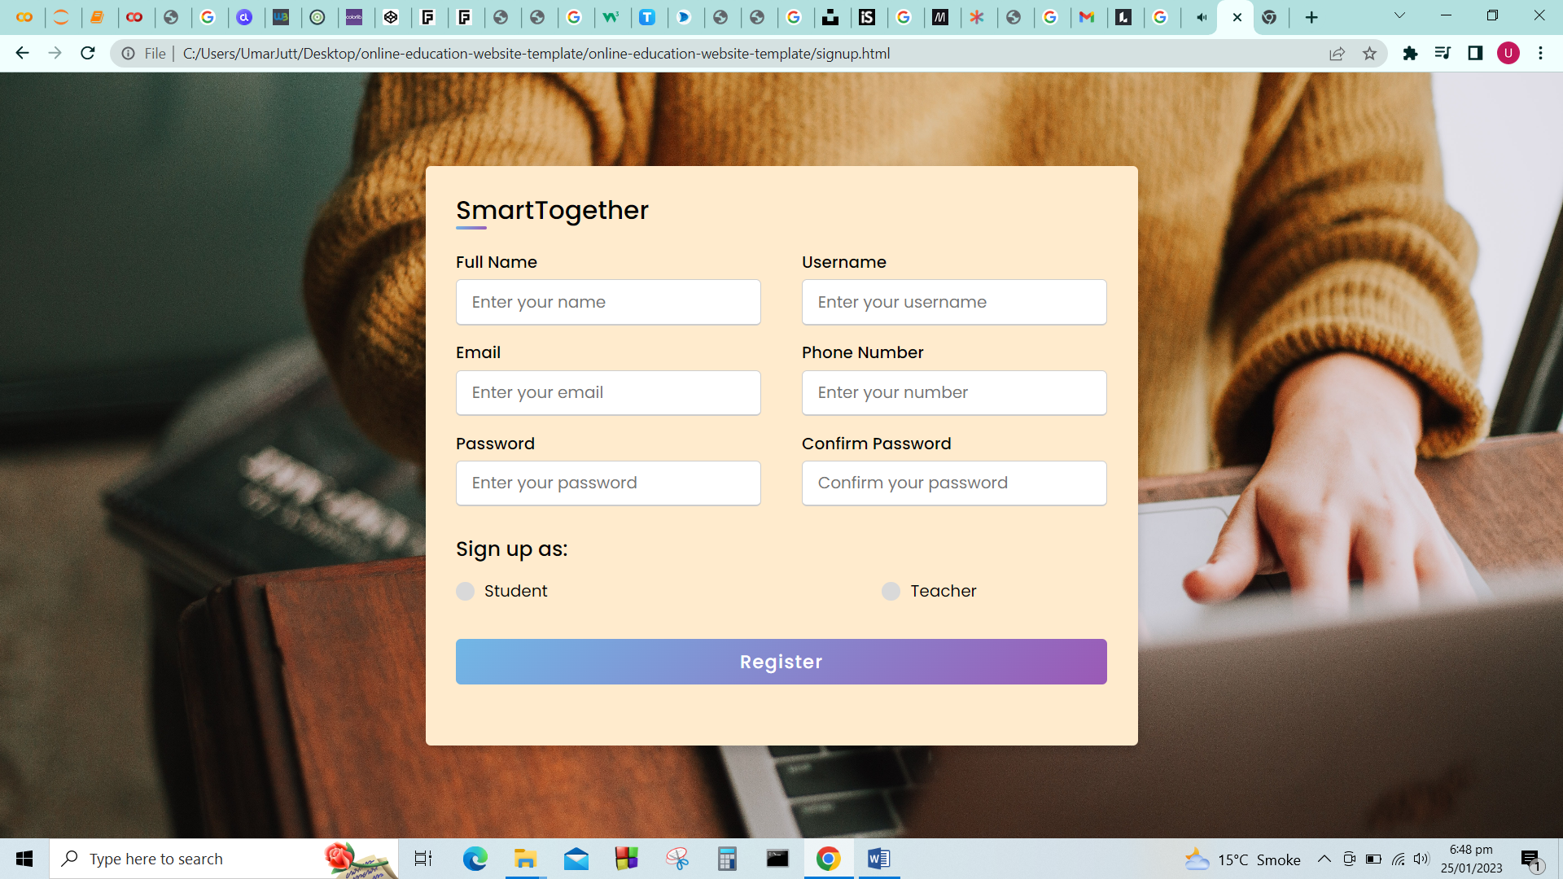

### Prototype2: (P2) Sign-in

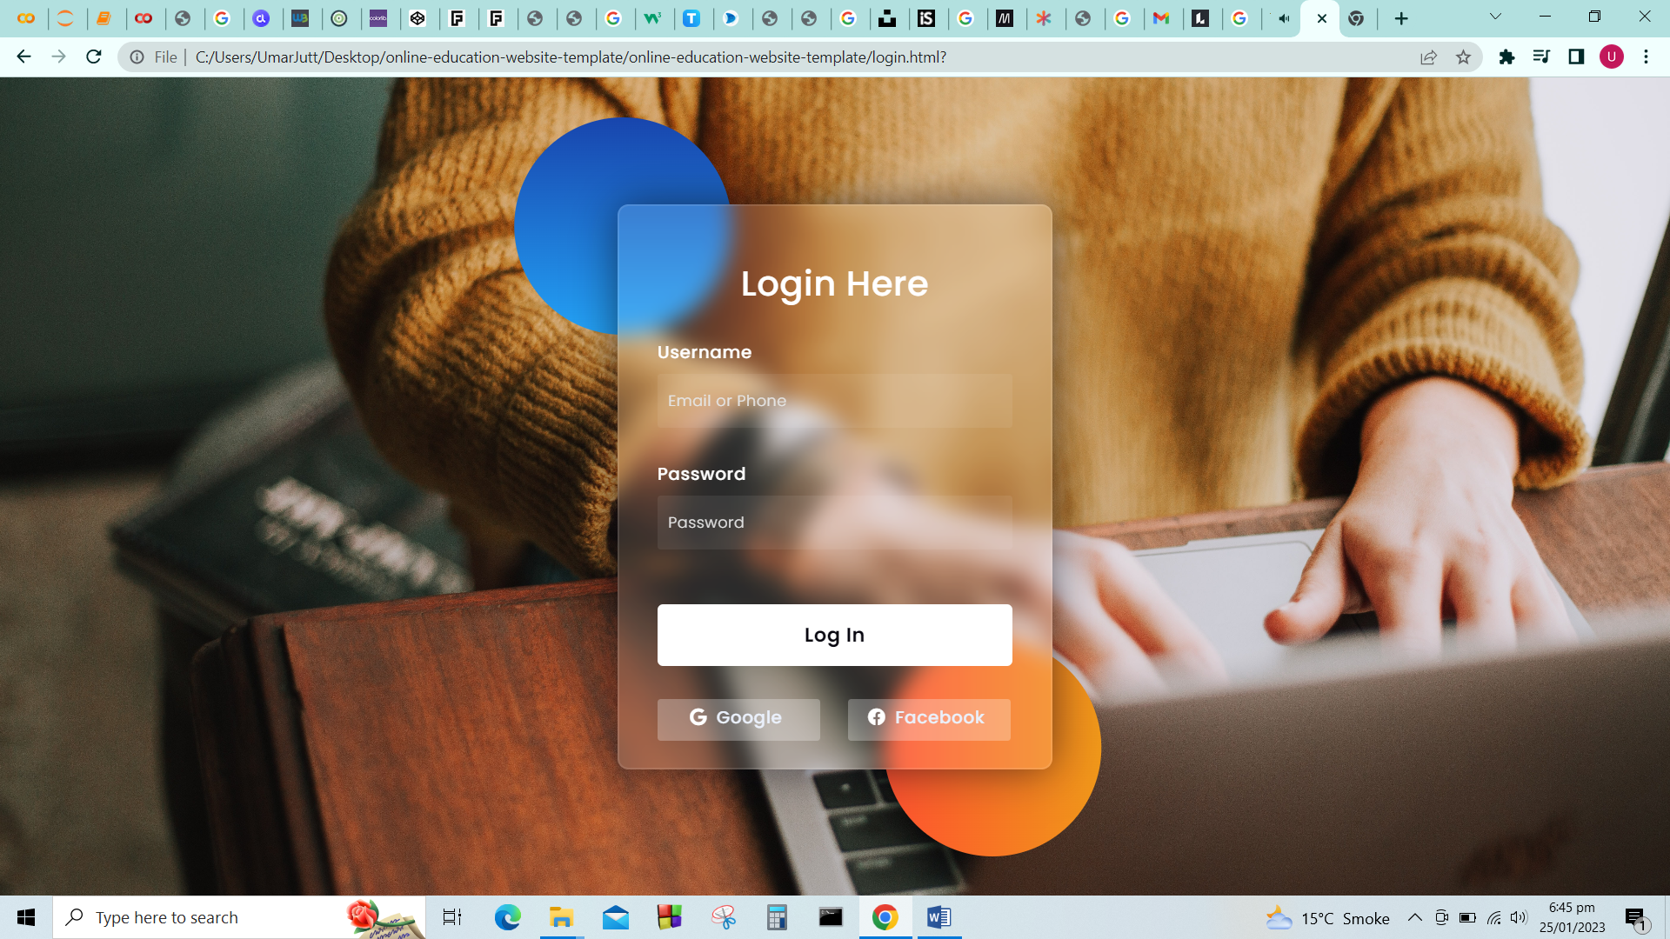

### Prototype3: (P3) Courses Page

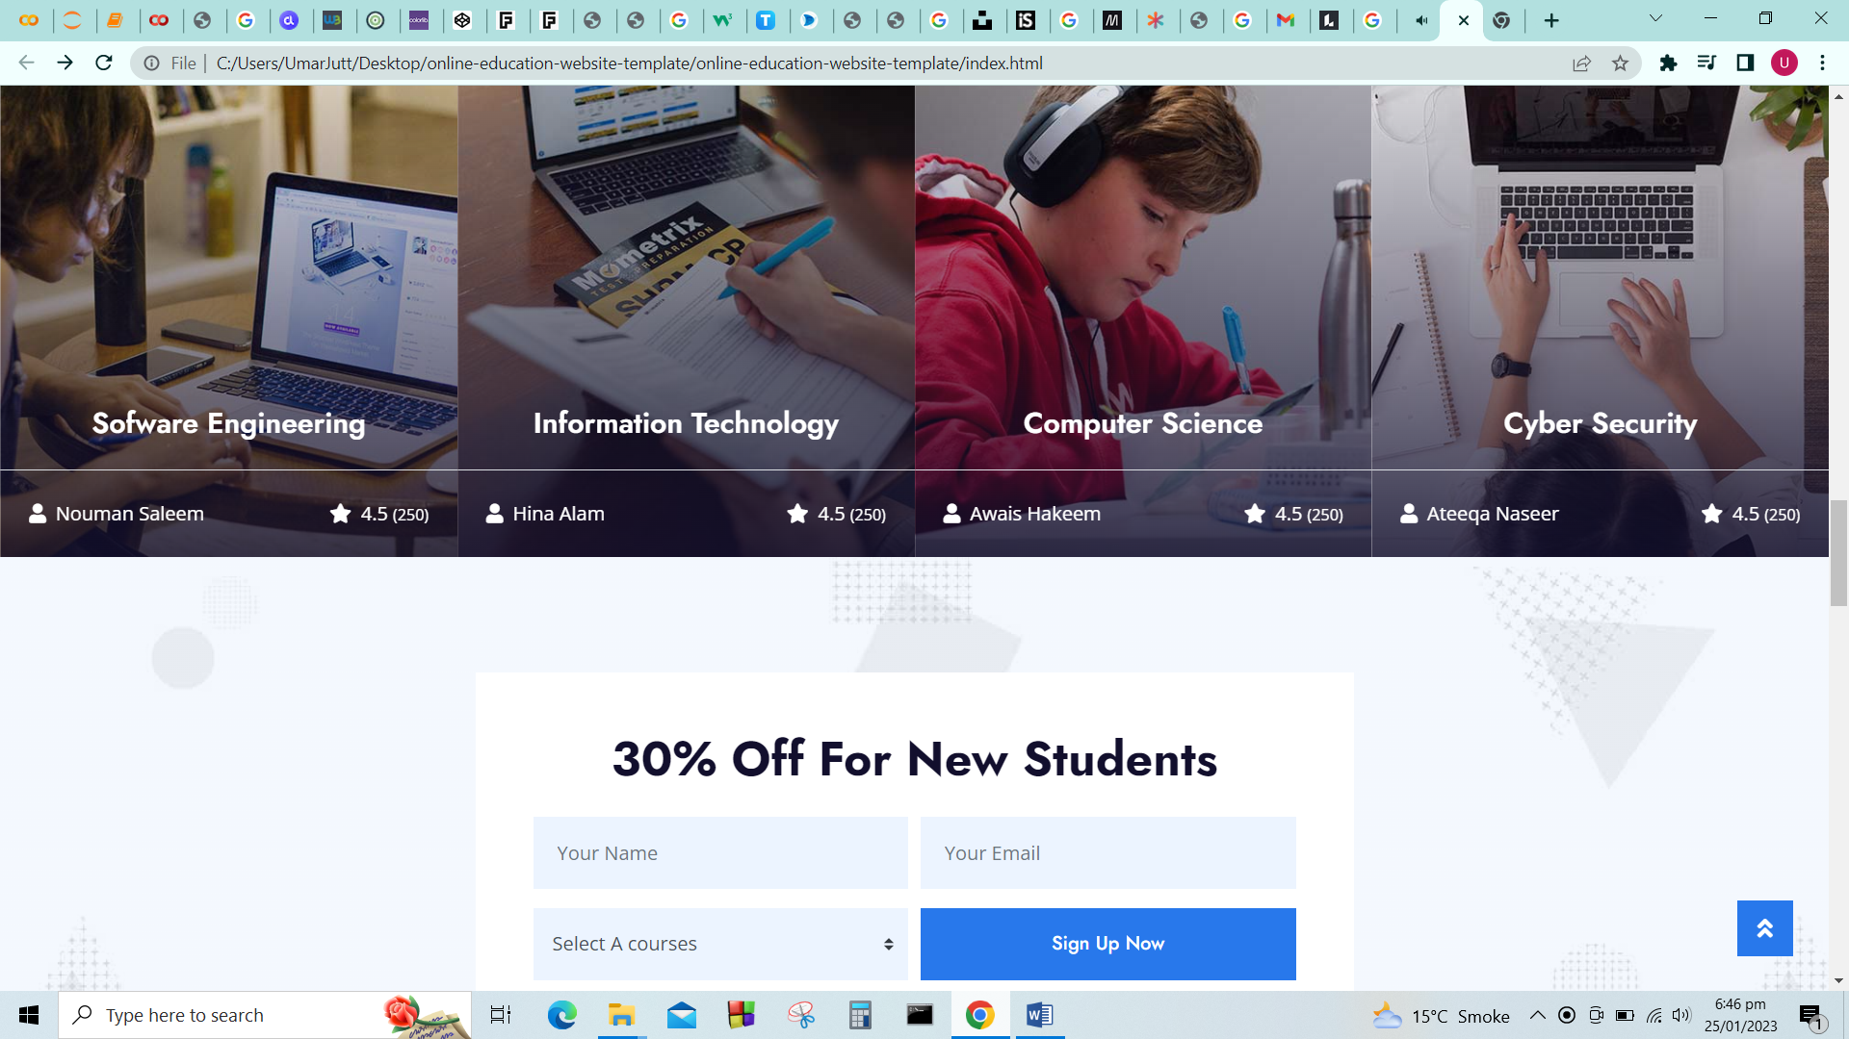

### Prototype4: (P4) Home Page

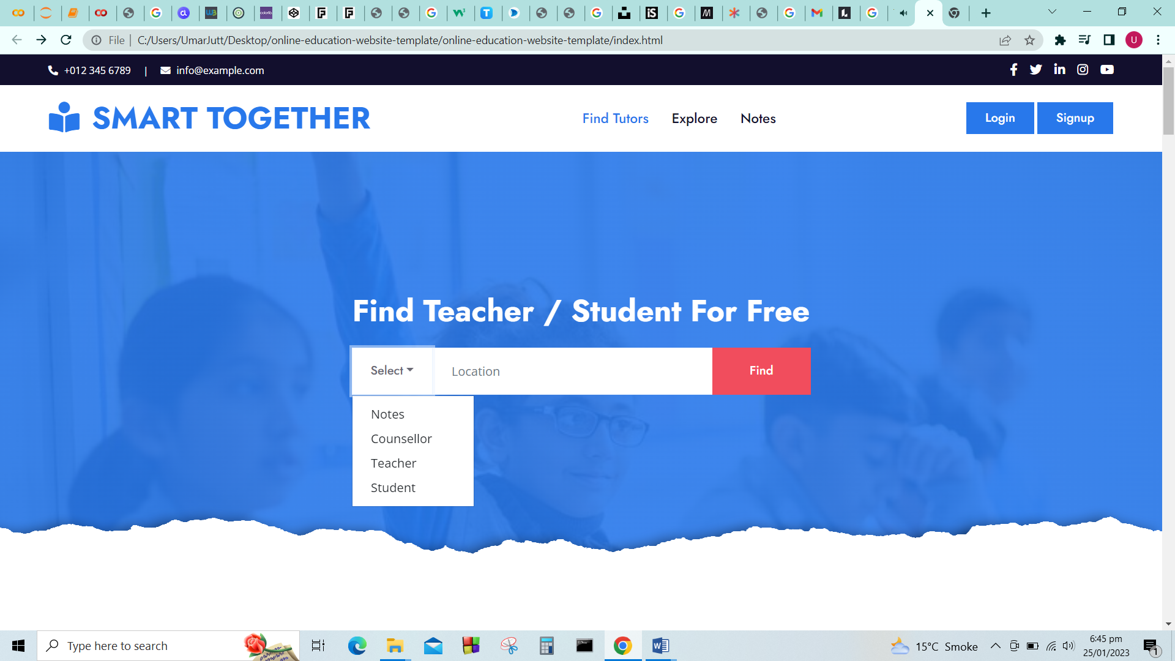

### Prototype5: (P5) About Page



# DFD

## DFD Level 0

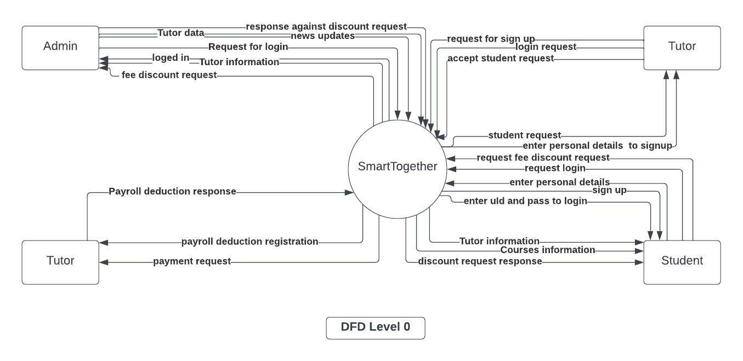

## DFD Level 1

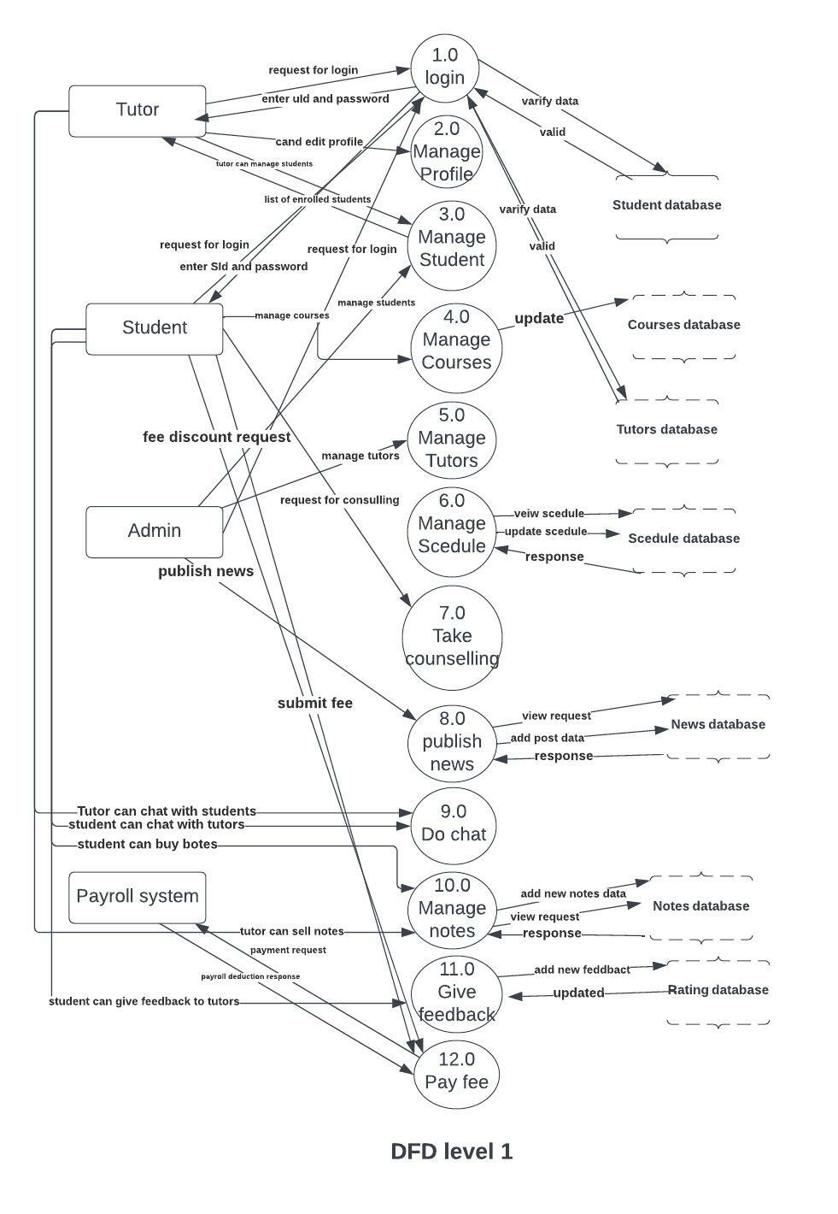

# DESIGN OF SYSTEM

## SAD

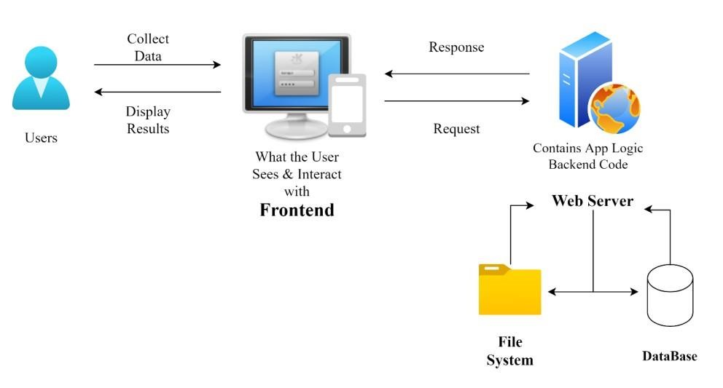

SYSTEM ARCHITECTURE DIAGRAM

## Class Diagram

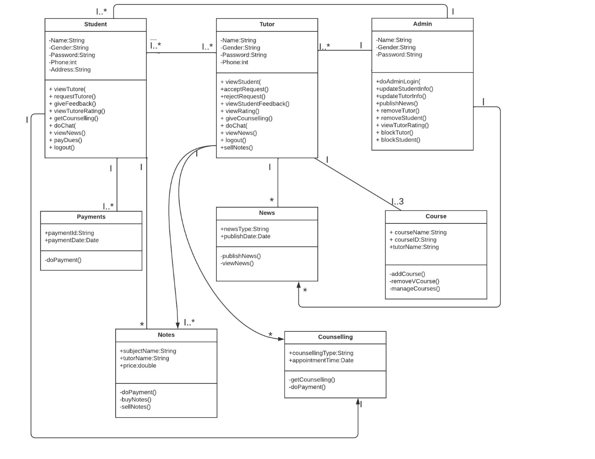

CLASS DIAGRAM

## Sequences

### Sign up

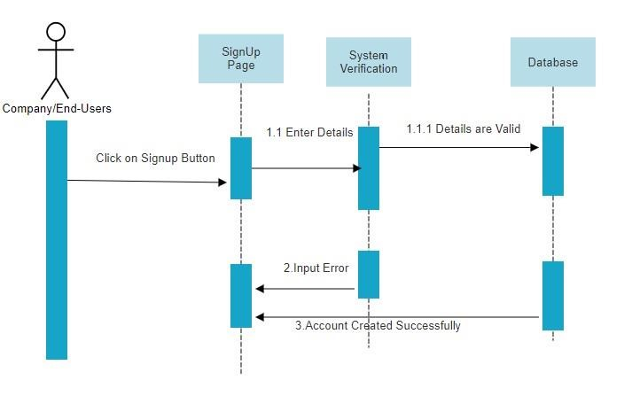

SEQUENCE DIAGRAM

### Sign-in

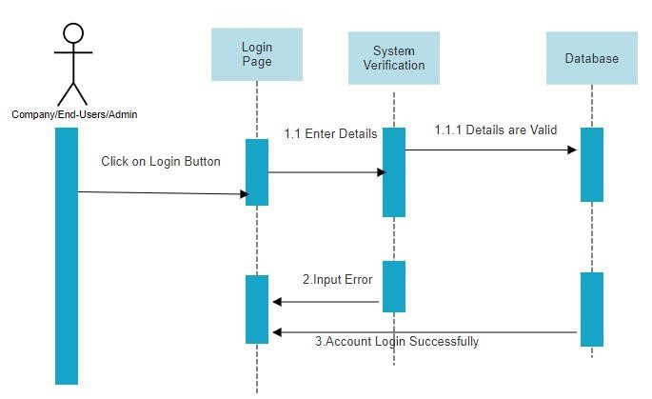

SIGN IN

### Change Password

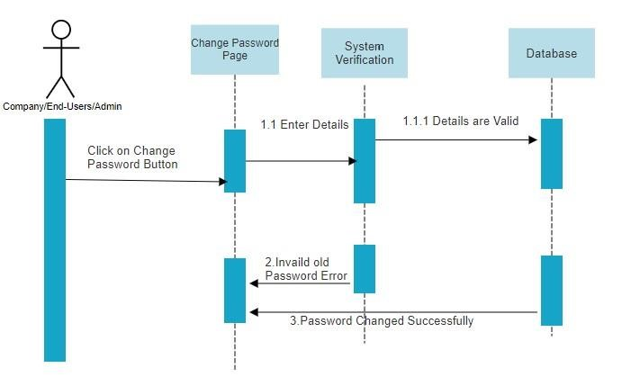

CHANGE PASSWORD

### Publish News

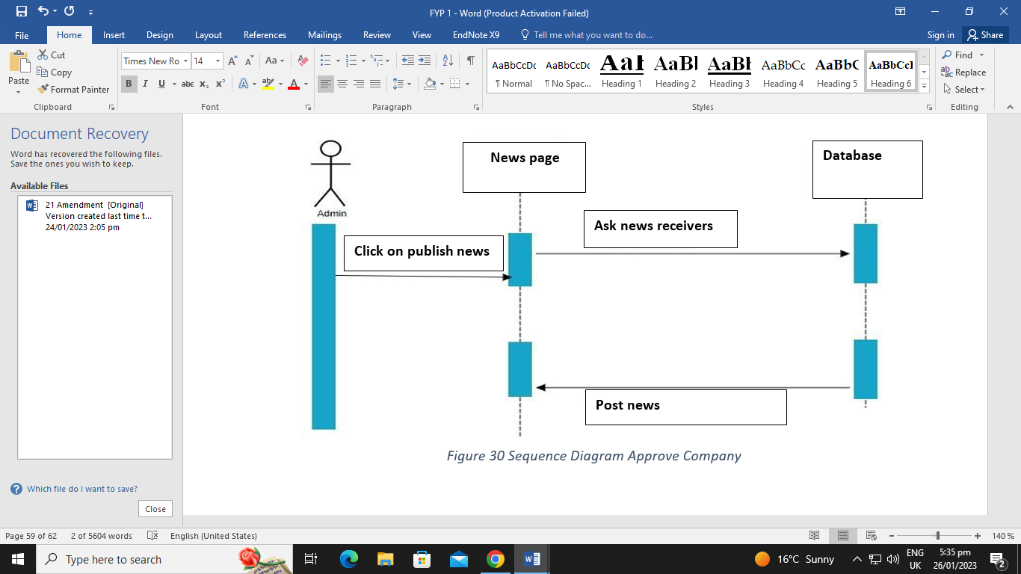

PUBLISH NEWS

### Email Verification

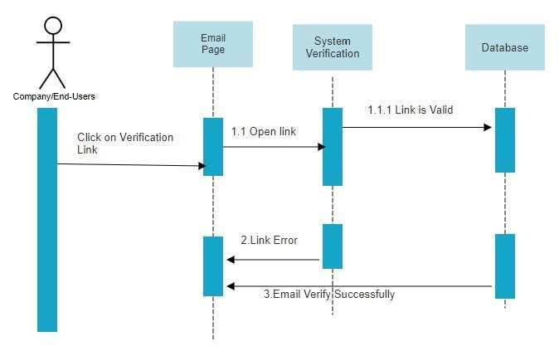

VERIFICATION

### Give Feedbacks

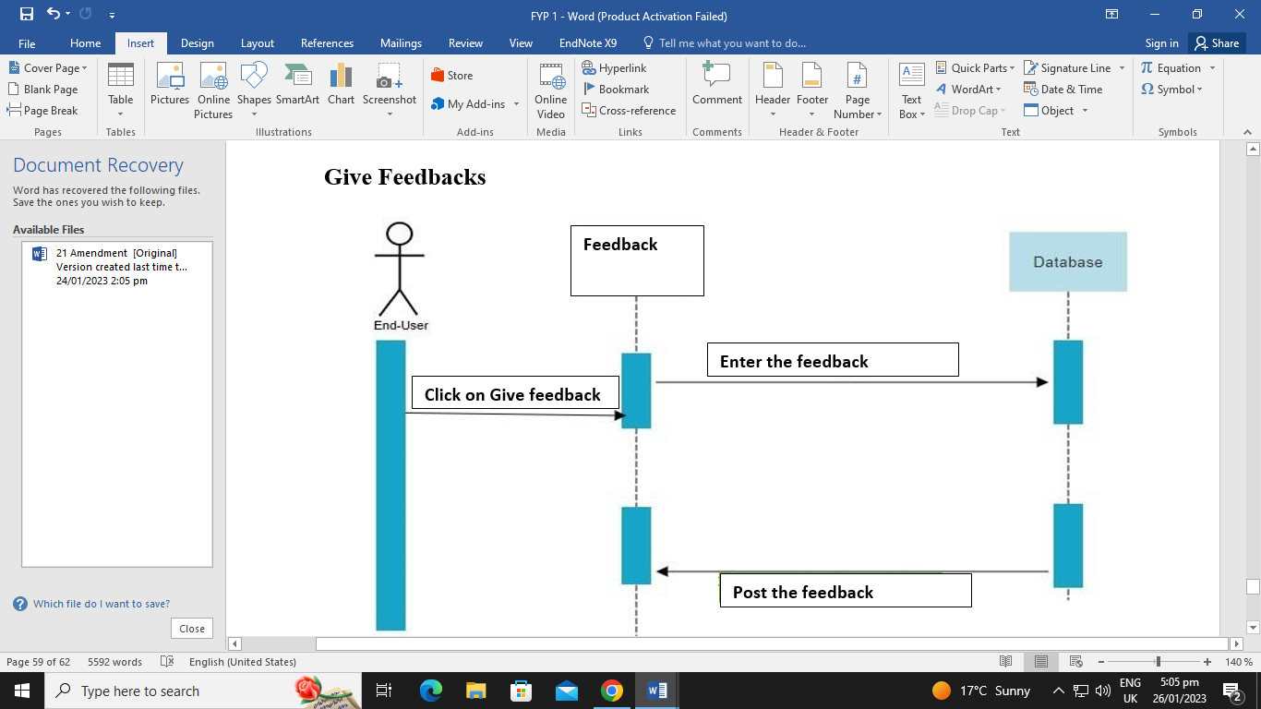

FEEDBACK

### Logout

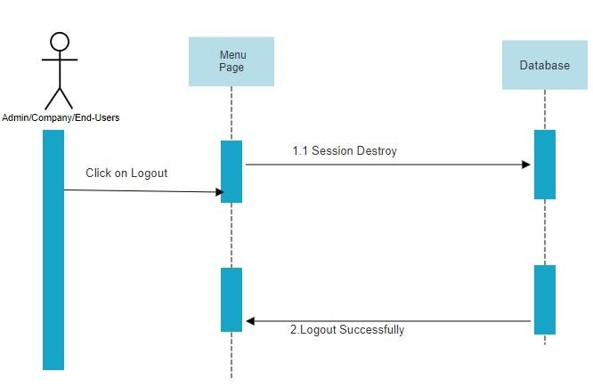

LOGOUT

## ERD

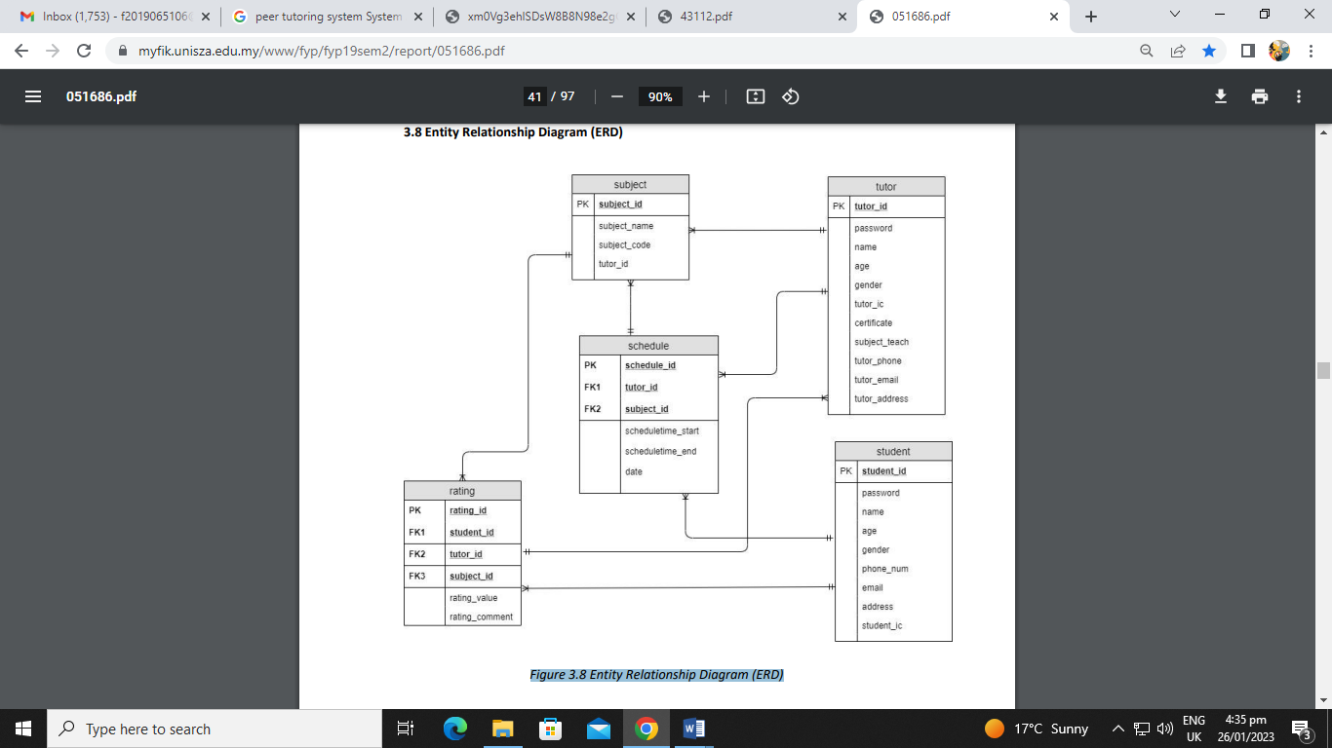

ERD

## Collaboration Diagram

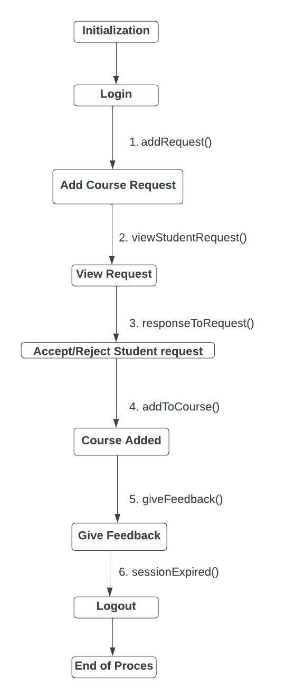

COLLABORATION DIAGRAM

# Development Setup

**React:**

It is a java script library utilized for building intuitive electronic connection points and web applications rapidly and productively with less code when contrasted with straightforward java script.

**Visual Studio code:**

A free coding manager assists you with coding in any programming language without exchanging proofreader.

**Mongo DB(Database)**

It is a data set used to construct profoundly accessible and versatile web applications.

**React Native:**

It is an open-source programming system used to foster applications for android and IOS.

**Node JS:**

## A well-known programming climate can be utilized for building high scale applications that requirements to help different simultaneous solicitations.

## Deployment setup

The system is deployed in a web-based application and both the admin and other users can use it according to their resources.

### Restrictions

There are no explicit restrictions on the system. The user can perform all the activities according to its role.

# Testing

## Extended Test Cases

|  |  |  |  |  |  |  |  |
| --- | --- | --- | --- | --- | --- | --- | --- |
| **ID: -** 1.1 | | | **By: Saeed khan** | | | | |
| **Name:** Create student Account | | | **Test on: 01-04-2022** | | | | |
| **Test need: -** High | | | **Test Executed by: Samar** | | | | |
| **Name**: To test functionalities of Create Account module. | | | **Test Executed Date: 12-05-2023** | | | | |
| **Depiction :** Check system behavior when selected with valid email id , valid password and valid name are entered. Registered is selected and then valid otp is enter. | | |  | | | | |
| **Pre-condition:**  PRE-1: User must be on sign up form  PRE-1: User must not have signed up | | | | | | | |
| **Conditions** | | | | | | | |
| **Step** | **Test step** | **Test Data** | | **Expected results** | **Actual results** | **Status** |  |
| 1 | 1. Go to site: 2. Select Get Started 3. Select Sign up 4. Enter Valid Email 5. Enter Valid Password 6. Enter Name 7. Select Register   Enter valid OTP | Email:  Password:  Name:  OPT : | | Student should be registered successful. | Student was registered successful | Pass |  |
|  | | | | | | | |

|  |  |  |  |  |  |  |  |
| --- | --- | --- | --- | --- | --- | --- | --- |
| **ID: -** 1.2 | | | **by: M Umar Farooq** | | | | |
| **Name:** Create Student Account | | | **Date: 10-05-2023** | | | | |
| **Priority: -** High | | | **Test Executed by: M Umar Farooq** | | | | |
| **Name**: To test functionalities of Create Student Account module. | | | **Test Executed Date: 12-05-2023** | | | | |
| **Description:** Check system behavior when selects a school with invalid email id, valid password and valid name are entered. Registered is selected and then valid otp is enter. | | |  | | | | |
| **Pre-condition:**  PRE-1: User must be on sign up form  PRE-1: User must not have signed up | | | | | | | |
| **Dependencies** | | | | | | | |
| **Step** | **Test step** | **Test Data** | | **Expected results** | **Actual results** | **Status** | **notes** |
| 1 | 1. Go to site: 2. Select Get Started 3. Select School Name 4. Enter invalid Email 5. Enter valid Password 6. Enter Name 7. Select Register   Enter valid OTP | Email:  Password:  Name:  OPT : | | Student shouldn’t be registered successful. | Student was not registered successful | Pass |  |
| **Post condition:**  POS_1: Message Occur Email is invalid  POS_1: Student is not Registered Successfully | | | | | | | |

|  |  |  |  |  |  |  |  |
| --- | --- | --- | --- | --- | --- | --- | --- |
| **ID: -** 1.3 | | | **by: M Umar Farooq** | | | | |
| **Name:** Create Student Account | | | **Date: 02-01-2022** | | | | |
| **Priority: -** High | | | **Test Executed by: Sana javed** | | | | |
| **Name**: To test functionalities of Create Student Account module. | | | **Test Executed Date: 12-05-2023** | | | | |
| **Description:** Check system behavior when selected with valid email id, invalid password and valid name are entered. Registered is selected and then valid otp is enter. | | |  | | | | |
| **Pre-condition:**  PRE-1: User must be on sign up form  PRE-1: User must not have signed up | | | | | | | |
| **Dependencies** | | | | | | | |
| **Step** | **Test step** | **Test Data** | | **Expected results** | **Actual results** | **Status** |  |
| 1 | 1. Go to site: 2. Select Get Started 3. Select Signup as Student 4. Enter invalid Email 5. Enter invalid Password 6. Enter Name 7. Select Register   Enter valid OTP | Email:  Password:  Name:  OPT : | | Student shouldn’t be registered successful. | Student was not registered successful | Pass |  |
| **Post condition:**  POS_1: Message Occur otp is invalid  POS_1: Student is not Registered Successfully | | | | | | | |

|  |  |  |  |  |  |  |  |
| --- | --- | --- | --- | --- | --- | --- | --- |
| **ID: -** 1.4 | | | **by: Kashif** | | | | |
| **Name:** Create Student Account | | | **Date: 30-02-2023** | | | | |
| **need: -** medium | | | **Test Executed by: Arshad** | | | | |
| **Name**: To test functionalities of Create Student Account module. | | | **Test Executed Date: 23-06-2023** | | | | |
| **Depiction:** Check system behavior when selected with valid email id, valid password and valid name are entered. Registered is selected and then invalid otp is enter. | | |  | | | | |
| **Pre-condition:**  PRE-1: User must be on sign up form  PRE-1: User must not have signed up | | | | | | | |
| **Dependencies** | | | | | | | |
| **Step** | **Test step** | **Test Data** | | **Expected results** | **Actual results** | **Status** |  |
| 1 | 1. Go to site: 2. Select Get Started 3. Select sign up as tutor 4. Enter invalid Email 5. Enter invalid Password 6. Enter Name 7. Select Register   Enter valid OTP | Email:  Password:  Name:  OPT : | | Student can’t registered successfully. | Student didn’t registered successfully | Pass |  |
| **Post condition:**  POS_1: Message Occur password is invalid  POS_1: Student is not Registered Successfully | | | | | | | |

|  |  |  |  |  |  |  |  |
| --- | --- | --- | --- | --- | --- | --- | --- |
| **ID: -** 1.5 | | | **by: Amir** | | | | |
| **Name:** Create Student Account | | | **Date: 07-07-2021** | | | | |
| **need: -** High | | | **Test Executed by: Halima** | | | | |
| **Name**: To test functionalities of Create Student Account module. | | | **Test Executed Date: 08-08-2021** | | | | |
| **Description:** Check system behavior when all fields are left blank & school is not selected | | |  | | | | |
| **Pre-condition:**  PRE-1: User must be on sign up form  PRE-1: User must not have signed up | | | | | | | |
| **Dependencies** | | | | | | | |
| **Step** | **Test step** | **Test Data** | | **Expected results** | **Actual results** | **Status** | **notes** |
| 1 | 1. Go to site:   Select Get Started | null | | Student shouldn’t be registered successful. | Student was not registered successful | Pass |  |
| **Post condition:**  POS_1: Message Occur Please Fill the form to register  POS_1: Student is not Registered Successfully | | | | | | | |

|  |  |  |  |  |  |  |  |
| --- | --- | --- | --- | --- | --- | --- | --- |
| **ID: -** 1.6 | | | **by: Sania** | | | | |
| **Name:** Create Student Account | | | **Date: 09-09-2023** | | | | |
| **Priority: -** High | | | **Test Executed by: Rafiq** | | | | |
| **Name**: To test functionalities of Create Student Account module. | | | **Test Executed Date: 03-03-2023** | | | | |
| **Description:** Check system behavior when all fields are left blank | | |  | | | | |
| **Pre-condition:**  PRE-1: User must be on sign up form  PRE-1: User must not have signed up | | | | | | | |
| **Dependencies** | | | | | | | |
| **Step** | **Test step** | **Test Data** | | **Expected results** | **Actual results** | **Status** |  |
| 1 | 1. Go to site:   Select Get Started | null | | Student can’t be registered successfully. | Student was not registered successful | Pass |  |
| **Post condition:**  POS_1: Message Occur Please Fill the form to register  POS_1: Student is not Registered Successfully | | | | | | | |
|  | | | | | | | |

|  |  |  |  |  |  |  |  |
| --- | --- | --- | --- | --- | --- | --- | --- |
| **ID: -** 2.1 | | | **by: Ashraf** | | | | |
| **Name:** Create Tutor Account | | | **Date: 05-05-2021** | | | | |
| **Priority: -** High | | | **Test Executed by: M Umar Farooq** | | | | |
| **Name**: To test functionalities of Create Tutor Account module. | | | **Test Executed Date: 10-10-2021** | | | | |
| **Description:** Check system behavior when valid name, valid email id, valid password, valid phone no, valid designation, valid department, valid faculty id are entered. Registered is selected and then valid otp is enter. | | |  | | | | |
| **Pre-condition:**  PRE-1: The user must be on sign up form  PRE-2: The user must not have signed up | | | | | | | |
| **Dependencies** | | | | | | | |
| **Step** | **Test step** | **Test Data** | | **Expected results** | **Actual results** | **Status** |  |
| 1 | 1. 1.Go to site: 2. Select Get Started 3. Enter valid Name 4. Enter Valid Email 5. Enter Valid Password 6. Enter valid phone no 7. Enter valid designation 8. Enter valid department 9. Select Register 10. Enter valid OTP | Name:  Email :  Password:  Phone no:  Designation:  Department:  Faculty id:  OTP : | | Tutor should be registered successful. | Tutor was registered successful |  |  |
| **Post condition:**  POS_1: Tutor Registered Successfully.  POS_2: Home Page is displayed. | | | | | | | |

|  |  |  |  |  |  |  |  |
| --- | --- | --- | --- | --- | --- | --- | --- |
| **ID: -** 2.2 | | | **by: Naila** | | | | |
| **Name:** Create Tutor Account | | | **Date: 10-05-2023** | | | | |
| **Priority: -** High | | | **by: Kabeer** | | | | |
| **Name**: To test functionalities of Create Tutor Account module. | | | **Test Executed Date: 12-05-2023** | | | | |
| **Description:** Check system behavior when valid name, valid email id , valid password, valid phone no, valid designation, valid department, valid faculty id are entered and Registered is selected and than valid otp is enter. | | |  | | | | |
| **Pre-condition:**  PRE-1: The user must be on sign up form  PRE-2: The user must not have signed up | | | | | | | |
| **Dependencies** | | | | | | | |
| **Step** | **Test step** | **Test Data** | | **Expected results** | **Actual results** | **Status** |  |
| 1 | 1. 1.Go to site: 2. Select Get Started 3. Enter valid Name 4. Enter Valid Email 5. Enter Valid Password 6. Enter valid phone no 7. Enter valid designation 8. Enter valid department 9. Select Register   Enter valid OTP | Name:  Email :  Password:  Phone no:  Designation:  Department:  Faculty id:  OTP : | | Tutor should be registered successful. | Tutor was registered successful | Pass |  |
| **Post condition:**  POS_1: Tutor Registered Successfully.  POS_2: Home Page is displayed. | | | | | | | |

|  |  |  |  |  |  |  |  |
| --- | --- | --- | --- | --- | --- | --- | --- |
| **ID: -** 2.3 | | | **by: Shafiq** | | | | |
| **Name:** Create Tutor Account | | | **Date: 10-05-2023** | | | | |
| **Test Priority: -** High | | | **Test Executed by: Jasim** | | | | |
| **Name**: To test functionalities of Create Professor Account module. | | | **Test Executed Date: 12-05-2023** | | | | |
| **Description:** Check system behavior when valid name, in valid email id, valid password, valid phone no, valid designation, valid department, valid faculty id is entered and Registered is selected and then valid opt is enter. | | |  | | | | |
| **Pre-condition:**  PRE-1: The user must be on sign up form.  PRE-2: The user must not have signed up. | | | | | | | |
| **Dependencies** | | | | | | | |
| **Step** | **Test step** | **Test Data** | | **Expected results** | **Actual results** | **Status** | **notes** |
| 1 | 1. 1.Go to site: 2. Select Get Started 3. Enter valid Name 4. Enter Valid Email 5. Enter Valid Password 6. Enter valid phone no 7. Enter valid designation 8. Enter valid department 9. Select Register   Enter valid OTP | Name:  Email :  Password:  Phone no:  Designation:  Department:  Faculty id:  OTP : | | Tutor should not be registered successful. | Tutor was not registered successful | Pass |  |
| **Post condition:**  POS_1: Message Occur Email is invalid  POS_2: Tutor is not Registered Successfully | | | | | | | |

|  |  |  |  |  |  |  |  |
| --- | --- | --- | --- | --- | --- | --- | --- |
| **ID: -** 2.4 | | | **by: Bilal Tariq** | | | | |
| **Name:** Create Tutor Account | | | **Date: 10-05-2023** | | | | |
| **Priority: -** High | | | **Test Executed by: Bilal Tariq** | | | | |
| **Name**: To test functionalities of Create Tutor Account module. | | | **Test Executed Date: 12-05-2023** | | | | |
| **Description:** Check system behavior when valid name, valid email id,  In valid password, valid phone no, valid designation, valid department, valid faculty id is entered and Registered is selected and then valid opt is enter. | | |  | | | | |
| **Pre-condition:**  PRE-1: The user must be on sign up form.  PRE-2: The user must not have signed up. | | | | | | | |
| **Dependencies** | | | | | | | |
| **Step** | **Test step** | **Test Data** | | **Expected results** | **Actual results** | **Status** | **notes** |
| 1 | 1. 1.Go to site: 2. Select Get Started 3. Enter valid Name 4. Enter Valid Email 5. Enter Valid Password 6. Enter valid phone no 7. Enter valid designation 8. Enter valid department 9. Select Register   Enter valid OTP | Name:  Email :  Password:  Phone no:  Designation:  Department:  Faculty id:  OTP : | | Tutor shouldnot be registered successful. | Tutor was not registered successful | Pass |  |
| **Post condition:**  POS_1: Message Occur Password is invalid.  POS_2: Tutor is not Registered Successfully. | | | | | | | |

|  |  |  |  |  |  |  |  |
| --- | --- | --- | --- | --- | --- | --- | --- |
| **ID: -** 2.5 | | | **by: Hamad** | | | | |
| **Name:** Create Tutor Account | | | **Date: 08-08-2022** | | | | |
| **Priority: -** High | | | **Test Executed by: Hammad** | | | | |
| **Name**: To test functionalities of Create Tutor Account module. | | | **Test Executed Date: 12-09-2022** | | | | |
| **Description:** Check system behavior when valid name, valid email id,  valid password, in valid phone no, valid designation, valid department, valid faculty id is entered and Registered is selected and then valid otp is enter. | | |  | | | | |
| **Pre-condition:**  PRE-1: The user must be on sign up form  PRE-2: The user must not have signed up | | | | | | | |
| **Dependencies** | | | | | | | |
| **Step** | **Test step** | **Test Data** | | **Expected results** | **Actual results** | **Status** |  |
| 1 | 1. 1.Go to site: 2. Select Get Started 3. Enter valid Name 4. Enter Valid Email 5. Enter Valid Password 6. Enter valid phone no 7. Enter valid designation 8. Enter valid department 9. Select Register   Enter valid OTP | Name:  Email :  Password:  Phone no:  Designation:  Department:  Faculty id:  OTP : | | Tutor should not be registered successful. | Tutor was not registered successful | Pass |  |
| **Post condition:**  POS_1: Message Occur Phone no is invalid  POS_2: Tutor is not Registered Successfully | | | | | | | |

|  |  |  |  |  |  |  |  |
| --- | --- | --- | --- | --- | --- | --- | --- |
| **ID: -** 2.6 | | | **by: Afridi** | | | | |
| **Name:** Create Tutor Account | | | **Date: 03-03-2020** | | | | |
| **need: -** High | | | **Test Executed by: Afridi** | | | | |
| **Name**: To test functionalities of Create Tutor Account module. | | | **Test Executed Date: 14-05-2020** | | | | |
| **Depiction:** Check system behavior when valid name, valid email id , valid password, valid phone no, in valid designation, valid department, valid faculty id are entered and Registered is selected and then valid otp is enter. | | |  | | | | |
| **Pre-condition:**  PRE-1: The user must be on sign up form  PRE-2: The user must not have signed up | | | | | | | |
| **Conditions** | | | | | | | |
| **Step** | **Test step** | **Test Data** | | **Expected results** | **Actual results** | **Status** |  |
| 1 | 1. 1.Go to site: 2. Select Get Started 3. Enter valid Name 4. Enter Valid Email 5. Enter Valid Password 6. Enter valid phone no 7. Enter valid designation 8. Enter valid department 9. Select Register   Enter valid OTP | Name:  Email :  Password:  Phone no:  Designation:  Department:  Faculty id:  OTP : | | Tutor should not be registered successful. | Tutor was not registered successful | Pass |  |
| **Post condition:**  POS_1: Message Occur designation is invalid  POS_2: Tutor is not Registered Successfully. | | | | | | | |

|  |  |  |  |  |  |  |  |
| --- | --- | --- | --- | --- | --- | --- | --- |
| **ID: -** 2.7 | | | **by: Ahmed** | | | | |
| **Name:** Create Tutor Account | | | **Date: 06-06-2023** | | | | |
| **Test Priority: -** High | | | **Test Executed by: Ahmed** | | | | |
| **Name**: To test functionalities of Create Tutor Account module. | | | **Test Executed Date: 04-04-2023** | | | | |
| **Description:** Check system behavior when valid name, valid email id , valid password, valid phone no, valid designation, in valid department, valid faculty id are entered and Registered is selected and then valid otp is enter. | | |  | | | | |
| **Pre-condition:**  PRE-1: The user must be on sign up form  PRE-2: The user must not have signed up | | | | | | | |
| **Dependencies** | | | | | | | |
| **Step** | **Test step** | **Test Data** | | **Expected results** | **Actual results** | **Status** |  |
| 1 | 1. 1.Go to site: 2. Select Get Started 3. Enter valid Name 4. Enter Valid Email 5. Enter Valid Password 6. Enter valid phone no 7. Enter valid designation 8. Enter valid department 9. Select Register   Enter valid OTP | Name:  Email :  Password:  Phone no:  Designation:  Department:  Faculty id:  OTP : | | Tutor shouldnot be registered successful. | Tutor was not registered successful | Pass |  |
| **Post condition:**  POS_1: Message Occur Department is invalid .  POS_2: Tutor is not Registered Successfully. | | | | | | | |

|  |  |  |  |  |  |  |  |
| --- | --- | --- | --- | --- | --- | --- | --- |
| **ID: -** 2.8 | | | **by: Naeem** | | | | |
| **Name:** Create Tutor Account | | | **Date: 10-05-2023** | | | | |
| **Priority: -** High | | | **Test Executed by: Naeem** | | | | |
| **Name**: To test functionalities of Create Tutor Account module. | | | **Test Executed Date: 12-05-2023** | | | | |
| Description: Check system behavior when valid name, valid email id ,  valid password, valid phone no, valid designation, valid department, in valid faculty id are entered and Registered is selected and than valid otp is enter. | | |  | | | | |
| **Pre-condition:**  PRE-1: The user must be on sign up form  PRE-2: The user must not have signed up | | | | | | | |
| **Dependencies** | | | | | | | |
| **Step** | **Test step** | **Test Data** | | **Expected results** | **Actual results** | **Status** |  |
| 1 | 1. 11.Go to site: 2. Select Get Started 3. Enter valid Name 4. Enter Valid Email 5. Enter Valid Password 6. Enter valid phone no 7. Enter valid designation 8. Enter valid department 9. Select Register   Enter valid OTP | Name:  Email :  Password:  Phone no:  Designation:  Department:  Faculty id:  OTP : | | Tutor should not be registered successful. | Tutor was not registered successful | Pass |  |

|  |
| --- |
| **Post condition:**  POS_1: Message Occur OTP is invalid  POS_2: Tutor is not Registered Successfully |

|  |  |  |  |  |  |  |  |
| --- | --- | --- | --- | --- | --- | --- | --- |
| **ID: -** 2.9 | | | **by: Ali** | | | | |
| **Name:** Create Tutor Account | | | **Date: 04-04-2022** | | | | |
| **Priority: -** High | | | **Test Executed by: Ali** | | | | |
| **Name**: To test functionalities of Create Tutor Account module. | | | **Test Executed Date: 03-03-2022** | | | | |
| **Description:** Check system behavior when valid name, valid email id ,  valid password, valid phone no, valid designation, valid department, valid faculty id are entered and Registered is selected and than in valid otp is enter. | | |  | | | | |
| **Pre-condition:**  PRE-1: The user must be on sign up form  PRE-2: The user must not have signed up | | | | | | | |
| **Dependencies** | | | | | | | |
| **Step** | **Test step** | **Test Data** | | **Expected results** | **Actual results** | **Status** |  |
| 1 | 1. 1.Go to site: 2. Select Get Started 3. Enter valid Name 4. Enter Valid Email 5. Enter Valid Password 6. Enter valid phone no 7. Enter valid designation 8. Enter valid department 9. Select Register   Enter valid OTP | Name:  Email :  Password:  Phone no:  Designation:  Department:  Faculty id:  OTP : | | Tutor should not be registered successful. | Tutor was not registered successful | Pass |  |
| **Post condition:**  POS_1: Message Occur OTP is invalid  POS_2: Professor is not Registered Successfully. | | | | | | | |

|  |  |  |  |  |  |  |  |
| --- | --- | --- | --- | --- | --- | --- | --- |
| **Experiment ID: -** 2.10 | | | | **by: IQbal** | | | |
| **Name:** Create Tutor Account | | | | **Date: 07-07-2021** | | | |
| **need: -** High | | | | **Test Executed by: Iqbal** | | | |
| **Name**: To test functionalities of Create Tutor Account module. | | | | **Test Executed Date: 11-11-2021** | | | |
| **Depiction:** Check system behavior when all fields are left blank. | | | |  | | | |
| **Pre-condition:**  PRE-1: The user must be on sign up form.  PRE-2: The user must not have signed up . | | | | | | | |
| **Dependencies** | | | | | | | |
| **Step** | **Test step** | **Test Data** | **Expected results** | | **Actual results** | **Status** |  |
| 1 | 1. 1.Go to site: 2. Select Get Started 3. Enter valid Name 4. Enter Valid Email 5. Enter Valid Password 6. Enter valid phone no 7. Enter valid designation 8. Enter valid department 9. Select Register   Enter valid OTP valid OTP | NULL | Tutor could not registered successfully. | | Tutor not registered successfully. | Pass |  |
| **Post condition:**  POS_1: Message Occur Fill the form to register  POS_2: Tutor is not Registered Successfully. | | | | | | | |

|  |  |  |  |  |  |  |  |
| --- | --- | --- | --- | --- | --- | --- | --- |
| **ID: -** 3.1 | | | **by: Areesha** | | | | |
| **Name:** Login | | | **Date: 01-01-2020** | | | | |
| **Priority: -** High | | | **Test Executed by: Areesha** | | | | |
| **Name**: To test functionalities of Login. | | | **Test Executed Date: 02-02-2020** | | | | |
| **Description:** Check system behavior when valid email id and password are entered and Log in entered. | | |  | | | | |
| **Pre-condition:**  PRE-1: The user must have signed up | | | | | | | |
| **Dependencies** | | | | | | | |
| **Step** | **Test step** | **Test Data** | | **Expected results** | **Actual results** | **Status** |  |
| 1 | 1. Go to site: 2. Enter a valid Email 3. Enter a valid Password   select Log-in. | Email :  Password: | | Login should be successful. | Login was successful | Pass |  |
| **Post condition:**  POS_1: Login Successful  POS_2: Home Page is displayed | | | | | | | |

|  |  |  |  |  |  |  |  |
| --- | --- | --- | --- | --- | --- | --- | --- |
| **ID: -** 3.2 | | | **by: Saima** | | | | |
| **Name:** Login | | | **Date: 06-06-2023** | | | | |
| **Test need: -** High | | | **Test Executed by: Saima** | | | | |
| **Name**: To test functionalities of Login. | | | **Test Executed Date: 12-12-2023** | | | | |
| **Depiction:** Check system behavior when invalid email id and valid password are entered and Log in entered. | | |  | | | | |
| **Pre-condition:**  PRE-1: The user must have signed up | | | | | | | |
| **Conditions** | | | | | | | |
| **Step** | **Test step** | **Test Data** | | **Expected results** | **Actual results** | **Status** |  |
| 1 | 1. Go to site: 2. Enter a invalid Email 3. Enter a valid Password   select Log-in. | Email :  Password: | | Login shouldn't be successful. | Login was not successful |  |  |
| **Post condition:**  POS_1: Message is occurred that email is not valid | | | | | | | |

|  |  |  |  |  |  |  |  |
| --- | --- | --- | --- | --- | --- | --- | --- |
| **ID: -** 3.3 | | | **by: Hina** | | | | |
| **Name:** Login | | | **Date: 08-08-2022** | | | | |
| **Test need: -** High | | | **Test Executed by: Hina** | | | | |
| **Name**: To test functionalities of Login. | | | **Test Executed Date: 1-9-2023** | | | | |
| **Depiction:** Check system behavior when email id and password are left blank and Log in is entered. | | |  | | | | |
| **Pre-condition:**  PRE-1: The user must have signed up | | | | | | | |
| **Conditions** | | | | | | | |
| **Step** | **Test step** | **Test Data** | | **Expected results** | **Actual results** | **Status** |  |
| 1 | 1. Go to site:   Select Log-in. | NULL | | Login shouldn't be successful. | Login was not successful | Pass |  |
| **Post condition:**  POS_1: Message is occurred that Bad credentials | | | | | | | |

|  |  |  |  |  |  |  |  |
| --- | --- | --- | --- | --- | --- | --- | --- |
| **ID: -** 3.4 | | | **by: Ashraf** | | | | |
| **Name:** Login | | | **Date: 10-05-2023** | | | | |
| **Priority: -** High | | | **Test Executed by: Ashraf** | | | | |
| **Name**: To test functionalities of Login. | | | **Test Executed Date: 12-05-2023** | | | | |
| **Description:** Check system behavior when valid email id and invalid password are entered and Log in entered. | | |  | | | | |
| **Pre-condition:**  PRE-1: The user must have signed up | | | | | | | |
| **Dependencies** | | | | | | | |
| **Step** | **Test step** | **Test Data** | | **Expected results** | **Actual results** | **Status** |  |
| 1 | 1. Go to site: 2. Enter a valid Email 3. Enter a invalid Password 4. Select Log-in. | Email :  Password: | | Login shouldn't be successful. | Login was not successful | Pass |  |
| **Post condition:**  POS_1: Message is occurred that Bad credentials | | | | | | | |

|  |  |  |  |  |  |  |  |
| --- | --- | --- | --- | --- | --- | --- | --- |
| **ID: -** 3.5 | | | **by: Aslam** | | | | |
| **Name:** Login | | | **Date: 2-02-2022** | | | | |
| **Priority: -** High | | | **Test Executed by: Aslam** | | | | |
| **Name**: To test functionalities of Login. | | | **Test Executed Date: 3-3-2022** | | | | |
| **Description:** Check system behavior when valid email id and invalid password are entered and Log in entered. | | |  | | | | |
| **Pre-condition:**  PRE-1: The user must have signed up | | | | | | | |
| **Dependencies** | | | | | | | |
| **Step** | **Test step** | **Test Data** | | **Expected results** | **Actual results** | **Status** |  |
| 1 | 1. Go to site: 2. Enter a valid Email 3. Enter a invalid Password 4. Select Log-in. | Email :  Password: | | Login shouldn't be successful. | Login was not successful | Pass |  |
| **Post condition:**  POS_1: Message is occurred that Bad credentials | | | | | | | |

|  |  |  |  |  |  |  |  |
| --- | --- | --- | --- | --- | --- | --- | --- |
| **ID: -** 4.1 | | | **by: Hafeez** | | | | |
| **Name:** Add a Tutor | | | **Date: 1-5-23** | | | | |
| **Priority: -** High | | | **Test Executed by: Hafeez** | | | | |
| **Name**: To test functionalities of Add a Professor | | | **Test Executed Date: 2-6-23** | | | | |
| **Description:** Check system behavior when a valid First Name, valid Last Name, valid password, valid courses, valid email, valid designation and valid phone no is entered and add professor is selected. | | |  | | | | |
| **Pre-condition:**  PRE-1: The user must have logged in  PRE-2: The user must be Admin | | | | | | | |
| **Dependencies** | | | | | | | |
| **Step** | **Test step** | **Test Data** | | **Expected results** | **Actual results** | **Status** |  |
| 1 | 1. Go to site: 2. Login to the system 3. Select Manage Tutor 4. Select Add Tutor 5. Enter valid First Name 6. Enter valid Last Name 7. Enter valid Password 8. Enter valid courses 9. Enter valid email 10. Enter valid designation 11. Enter valid phone no 12. Select Add Tutor | First Name: Asif  Last Name: Subhani  Password: as.ds22  Courses: Machine Learning, IPhone application  Email : [asif.subhani@umt.edu.pk](mailto:asif.subhani@umt.edu.pk)  Designation: Assistant Tutor  Phone: 0313231212 | | Tutor added successfully | Tutor was added successfully | Pass |  |
| **Post condition:**  POS_1: Tutor will be added | | | | | | | |

|  |  |  |  |  |  |  |  |
| --- | --- | --- | --- | --- | --- | --- | --- |
| **ID: -** 4.2 | | | **by: Bushra** | | | | |
| **Name:** Add a Tutor | | | **Date: 1-1-22** | | | | |
| **Priority: -** High | | | **Test Executed by: Bushra** | | | | |
| **Name**: To test functionalities of Add a Tutor | | | **Test Executed Date: 2-2-2022** | | | | |
| **Description:** Check system behavior when a invalid First Name, valid Last Name, valid password, valid courses, valid email, valid designation and valid phone no is entered and add Tutor is selected. | | |  | | | | |
| **Pre-condition:**  PRE-1: The user must have logged in  PRE-2: The user must be Admin | | | | | | | |
| **Dependencies** | | | | | | | |
| **Step** | **Test step** | **Test Data** | | **Expected results** | **Actual results** | **Status** |  |
| 1 | 1. Go to site: 2. Login to the system 3. Select Manage Tutors 4. Select Add Tutor 5. Enter invalid First Name 6. Enter valid Last Name 7. Enter valid Password 8. Enter valid courses 9. Enter valid email 10. Enter valid designation 11. Enter valid phone no 12. Select Add Tutor | First Name: 332e3es  Last Name: Subhani  Password: as.ds22  Courses: Machine Learning, IPhone application  Email : [asif.subhani@umt.edu.pk](mailto:asif.subhani@umt.edu.pk)  Designation: Assistant Tutor  Phone: 0313231212 | | Tutor not added | Tutor was not added | Pass |  |
| **Post condition:**  POS_1: Error message will occur that first name is invalid | | | | | | | |

|  |  |  |  |  |  |  |  |
| --- | --- | --- | --- | --- | --- | --- | --- |
| **ID: -** 4.3 | | | **by: Alina** | | | | |
| **Name:** Add a Tutor | | | **Date: 1-5-23** | | | | |
| **Priority: -** High | | | **Test Executed by: Alina** | | | | |
| **Name**: To test functionalities of Add a Tutor | | | **Test Executed Date: 6-6-23** | | | | |
| **Description:** Check system behavior when a valid First Name, invalid Last Name, valid password, valid courses, valid email, valid designation and valid phone no is entered and add Tutor is selected. | | |  | | | | |
| **Pre-condition:**  PRE-1: The user must have logged in  PRE-2: The user must be Admin | | | | | | | |
| **Dependencies** | | | | | | | |
| **Step** | **Test step** | **Test Data** | | **Expected results** | **Actual results** | **Status** |  |
| 1 | 1. Go to site: 2. Login to the system 3. Select Manage Tutors 4. Select Add Tutor 5. Enter valid First Name 6. Enter invalid Last Name 7. Enter valid Password 8. Enter valid courses 9. Enter valid email 10. Enter valid designation 11. Enter valid phone no 12. Select Add Tutor | First Name: Asif  Last Name: Subhani12  Password: as.ds22  Courses: Machine Learning, IPhone application  Email : [asif.subhani@umt.edu.pk](mailto:asif.subhani@umt.edu.pk)  Designation: Assistant Tutor  Phone: 0313231212 | | Tutor not added | Tutor was not added | Pass |  |
| **Post condition:**  POS_1: Error message will occur that last name is invalid | | | | | | | |

|  |  |  |  |  |  |  |  |
| --- | --- | --- | --- | --- | --- | --- | --- |
| **ID: -** 4.4 | | | **by: Aliza** | | | | |
| **Name:** Add a Tutor | | | **Date: 6-6-20** | | | | |
| **Test Priority: -** High | | | **Test Executed by: Aliza** | | | | |
| **Name**: To test functionalities of Add a Tutor | | | **Test Executed Date: 7-7-20** | | | | |
| **Description:** Check system behavior when a valid First Name, valid Last Name, invalid password, valid courses, valid email, valid designation and valid phone no is entered and add Tutor is selected. | | |  | | | | |
| **Pre-condition:**  PRE-1: The user must have logged in  PRE-2: The user must be Admin | | | | | | | |
| **Dependencies** | | | | | | | |
| **Step** | **Test step** | **Test Data** | | **Expected results** | **Actual results** | **Status** |  |
| 1 | 1. Go to site: 2. Login to the system 3. Select Manage Tutor 4. Select Add Tutor 5. Enter valid First Name 6. Enter valid Last Name 7. Enter invalid Password 8. Enter valid courses 9. Enter valid email 10. Enter valid designation 11. Enter valid phone no 12. Select Add Tutor | First Name: Asif  Last Name: Subhani  Password: 458785  Courses: Machine Learning, IPhone application  Email : [asif.subhani@umt.edu.pk](mailto:asif.subhani@umt.edu.pk)  Designation: Assistant Tutor  Phone: 0313231212 | | Tutor not added | Tutor was not added | Pass |  |
| **Post condition:**  POS_1: Error message will occur that password is invalid | | | | | | | |

|  |  |  |  |  |  |  |  |
| --- | --- | --- | --- | --- | --- | --- | --- |
| **ID: -** 4.5 | | | **by: Akram** | | | | |
| **Test Module Name:** Add a Tutor | | | **Date: 1-1-22** | | | | |
| **Test need : -** medium | | | **Test Executed by: Akram** | | | | |
| **Name**: To test functionalities of Add a Tutor | | | **Test Executed Date: 2-2-22** | | | | |
| **Depiction:** Check system behavior when a valid First Name, valid Last Name, valid password, invalid courses, valid email, valid designation and valid phone no is entered and add Tutor is selected. | | |  | | | | |
| **Pre-condition:**  PRE-1: The user must have logged in  PRE-2: The user must be university representative or Admin | | | | | | | |
| **Conditions** | | | | | | | |
| **Step** | **Test step** | **Test Data** | | **Expected results** | **Actual results** | **Status** |  |
| 1 | 1. Go to site: 2. Login to the system 3. Select Manage Tutor 4. Select Add Tutor 5. Enter valid First Name 6. Enter valid Last Name 7. Enter valid Password 8. Enter invalid courses 9. Enter valid email 10. Enter valid designation 11. Enter valid phone noSelect Add Tutor | First Name: Asif  Last Name: Subhani  Password: asd.5423  Courses: yufuuygu  Email : [asif.subhani@umt.edu.pk](mailto:asif.subhani@umt.edu.pk)  Designation: Assistant Tutor  Phone: 0313231212 | | Tutor not added | Tutor was not added | Pass |  |
| **Post condition:**  POS_1: Error message will occur that password is invalid | | | | | | | |

|  |  |  |  |  |  |  |  |
| --- | --- | --- | --- | --- | --- | --- | --- |
| **ID: -** 4.6 | | | **by: Idrees** | | | | |
| **Name:** Add a Tutor | | | **Date: 1-09-2023** | | | | |
| **Priority: -** Low | | | **Test Executed by: Idrees** | | | | |
| **Name**: To test functionalities of Add a Tutor | | | **Test Executed Date: 02-10-2023** | | | | |
| **Description:** Check system behavior when a valid First Name, valid Last Name, valid password, valid courses, invalid email, valid designation and valid phone no is entered and add Tutor is selected. | | |  | | | | |
| **Pre-condition:**  PRE-1: The user must have logged in  PRE-2: The user must be Admin | | | | | | | |
| **Dependencies** | | | | | | | |
| **Step** | **Test step** | **Test Data** | | **Expected results** | **Actual results** | **Status** |  |
| 1 | 1. Go to site: 2. Login to the system 3. Select Manage Tutor 4. Select Add Tutor 5. Enter valid First Name 6. Enter valid Last Name 7. Enter valid Password 8. Enter invalid courses 9. Enter invalid email 10. Enter valid designation 11. Enter valid phone no 12. Select Add Tutor | First Name: Asif  Last Name: Subhani  Password: asd.213  Courses: Machine Learning, IPhone application  Email : [asif.subhaniumt.edu.pk](mailto:asif.subhani@umt.edu.pk)  Designation: Assistant Tutor  Phone: 0313231212 | | Tutor not added | Tutor was not added | Pass |  |
| **Post condition:**  POS_1: Error message will occur that email is invalid | | | | | | | |

|  |  |  |  |  |  |  |  |
| --- | --- | --- | --- | --- | --- | --- | --- |
| **ID: -** 4.7 | | | **by: Hareem** | | | | |
| **Test Module Name:** Adding Tutor | | | **Date: 11-11-2022** | | | | |
| **Priority: -** Medium | | | **Test Executed by: Hareem** | | | | |
| **Name**: To test functionalities of Add a Tutor | | | **Test Executed Date: 12-12-2022** | | | | |
| **Description:** Check system behavior when a valid First Name, valid Last Name, valid password, valid courses, valid email, invalid designation and valid phone no is entered and add Tutor is selected. | | |  | | | | |
| **Pre-condition:**  PRE-1: The user must have logged in  PRE-2: The user must be Admin | | | | | | | |
| **Dependencies** | | | | | | | |
| **Step** | **Test step** | **Test Data** | | **Expected results** | **Actual results** | **Status** |  |
| 1 | 1. Go to site: 2. Login to the system 3. Select Manage Tutor 4. Select Add Tutor 5. Enter valid First Name 6. Enter valid Last Name 7. Enter valid Password 8. Enter valid courses 9. Enter valid email 10. Enter invalid designation 11. Enter valid phone no 12. Select Add Tutor | First Name: Asif  Last Name: Subhani  Password: asd.213  Courses: Machine Learning, IPhone application  Email : [asif.subhani@umt.edu.pk](mailto:asif.subhani@umt.edu.pk)  Designation:  Phone: 0313231212 | | Tutor not added | Tutor was not added | Pass |  |
| **Post condition:**  POS_1: Error message will occur that designation is invalid | | | | | | | |

|  |  |  |  |  |  |  |  |
| --- | --- | --- | --- | --- | --- | --- | --- |
| **ID: -** 4.8 | | | **by: Sania** | | | | |
| **Name:** Adding Tutor | | | **Date: 1-1-23** | | | | |
| **Priority: -** Low | | | **Test Executed by: Sania** | | | | |
| **Name**: To test functionalities of Add a Tutor | | | **Test Executed Date: 2-2-23** | | | | |
| **Description:** Check system behavior when a valid First Name, valid Last Name, valid password, valid courses, valid email, valid designation and invalid phone no is entered and add Tutor is selected. | | |  | | | | |
| **Pre-condition:**  PRE-1: The user must have logged in  PRE-2: The user must be Admin | | | | | | | |
| **Dependencies** | | | | | | | |
| **Step** | **Test step** | **Test Data** | | **Expected results** | **Actual results** | **Status** |  |
| 1 | 1. Go to site: 2. Login to the system 3. Select Manage Tutor 4. Select Add Tutor 5. Enter valid First Name 6. Enter valid Last Name 7. Enter valid Password 8. Enter valid courses 9. Enter valid email 10. Enter valid designation 11. Enter invalid phone no 12. Select Add Tutor | First Name: Asif  Last Name: Subhani  Password: asd.213  Courses: Machine Learning, IPhone application  Email : [asif.subhani@umt.edu.pk](mailto:asif.subhani@umt.edu.pk)  Designation: Assistant Tutor  Phone: yug | | Tutor not added | Tutor was not added | Pass |  |
| **Post condition:**  POS_1: Error message will occur that phone no is invalid | | | | | | | |

|  |  |  |  |  |  |  |  |
| --- | --- | --- | --- | --- | --- | --- | --- |
| **ID: -** 5.1 | | | **by: Hajra** | | | | |
| **Name:** Update Tutor Account | | | **Date: 08-05-2023** | | | | |
| **Priority: -** Medium | | | **Test Executed by: Hajra** | | | | |
| **Name**: To test functionalities of Update a Tutor account | | | **Test Executed Date: 15-05-2023** | | | | |
| **Description:** Check system behavior when a valid email, valid designation, valid phone no and valid courses is entered and update Tutor account is selected. | | |  | | | | |
| **Pre-condition:**  PRE-1: The user must have logged in  PRE-2: The user must be Admin | | | | | | | |
| **Dependencies** | | | | | | | |
| **Step** | **Test step** | **Test Data** | | **Expected results** | **Actual results** | **Status** |  |
| 1 | 1. Go to site: 2. Login to the system 3. Select Manage Tutor 4. Select Update Tutor 5. Enter valid email 6. Enter valid designation 7. Enter valid phone no 8. Enter valid courses 9. Select Update Tutor Account | Email : [asif.subhani@umt.edu.pk](mailto:asif.subhani@umt.edu.pk)  Designation: Assistant Tutor  Phone: 0313231212  Courses: Machine Learning, IPhone application | | Tutor Account updated successfully | Tutor Account was updated successfull | Pass |  |
| **Post condition:**  POS_1: Tutor will be updated. | | | | | | | |

|  |  |  |  |  |  |  |  |
| --- | --- | --- | --- | --- | --- | --- | --- |
| **ID: -** 5.2 | | | **by: Tehreem** | | | | |
| **Name:** Update Tutor Account | | | **Date: 05-05-21** | | | | |
| **need : -** Medium | | | **by: M Waleed Khan** | | | | |
| **Name**: To test functionalities of Update a Tutor Account | | | **Test Executed Date: 06-06-21** | | | | |
| **Description:** Check system behavior when a invalid email, valid designation, valid phone no and valid courses is entered and update Tutor Account is selected. | | |  | | | | |
| **Pre-condition:**  PRE-1: The user must have logged in  PRE-2: The user must be Admin | | | | | | | |
| **Dependencies** | | | | | | | |
| **Step** | **Test step** | **Test Data** | | **Expected results** | **Actual results** | **Status** |  |
| 1 | 1. Go to site: 2. Login to the system 3. Select Manage Tutor Account 4. Select Update Tutor Account 5. Enter invalid email 6. Enter valid designation 7. Enter valid phone no 8. Enter valid courses   Select Update Tutor Account | Email : [asif.subhani@umt.edu.pk](mailto:asif.subhani@umt.edu.pk)  Designation: Assistant Tutor  Phone: 0313231212  Courses: Machine Learning, IPhone application | | Tutor Account not updated | Tutor Account was not updated | Pass |  |
| **Post condition:**  POS_1: Error message will occur that email is invalid | | | | | | | |

|  |  |  |  |  |  |  |  |
| --- | --- | --- | --- | --- | --- | --- | --- |
| **ID: -** 5.3 | | | **by: Zohaib** | | | | |
| **Name:** Update Tutor Account | | | **Date: 10-10-23** | | | | |
| **Priority: -** High | | | **Test Executed by: Zohaib** | | | | |
| **Name**: To test functionalities of Update a Tutor Account | | | **Test Executed Date: 11-11-23** | | | | |
| **Depiction:** Check system behavior when a valid email, invalid designation, valid phone no and valid courses is entered and update Tutor Account is selected. | | |  | | | | |
| **Pre-condition:**  PRE-1: The user must have logged in  PRE-2: The user must be Admin | | | | | | | |
| **Dependencies** | | | | | | | |
| **Step** | **Test step** | **Test Data** | | **Expected results** | **Actual results** | **Status** |  |
| 1 | 1. Go to site: 2. Login to the system 3. Select Manage Tutors 4. Select Update Tutor Account 5. Enter valid email 6. Enter invalid designation 7. Enter valid phone no 8. Enter valid courses   Select Update Tutor Account | Email : [asif.subhaniumt.edu.pk](mailto:asif.subhani@umt.edu.pk)  Designation: null121  Phone: 0313231212  Courses: Machine Learning, IPhone application | | Tutor Account not updated | Tutor Account was not updated | Pass |  |
| **Post condition:**  POS_1: Error message will occur that designation is invalid | | | | | | | |

|  |  |  |  |  |  |  |  |
| --- | --- | --- | --- | --- | --- | --- | --- |
| **ID: -** 5.4 | | | **by: Muhammad** | | | | |
| **Name:** Update Tutor Account | | | **Date: 6-6-20** | | | | |
| **Priority: -** High | | | **Test Executed by: Muhammad** | | | | |
| **Name**: To test functionalities of Update a Tutor Account | | | **Test Executed Date: 7-7-20** | | | | |
| **Description:** Check system behavior when a valid email, valid designation, invalid phone no and valid courses is entered and update Tutor Account is selected. | | |  | | | | |
| **Pre-condition:**  PRE-1: The user must have logged in  PRE-2: The user must be Admin | | | | | | | |
| **Dependencies** | | | | | | | |
| **Step** | **Test step** | **Test Data** | | **Expected results** | **Actual results** | **Status** |  |
| 1 | 1. Go to site: 2. Login to the system 3. Select Manage Tutor Account 4. Select Update Tutor Account 5. Enter valid email 6. Enter valid designation 7. Enter invalid phone no 8. Enter valid courses   Select Update Tutor Account | Email : [asif.subhaniumt.edu.pk](mailto:asif.subhani@umt.edu.pk)  Designation: Assistant  Phone: 768yt  Courses: Machine Learning, IPhone application | | Tutor Account not updated | Tutor Account was not updated | Pass |  |
| **Post condition:**  POS_1: Error message will occur that phone no is invalid | | | | | | | |

|  |  |  |  |  |  |  |  |
| --- | --- | --- | --- | --- | --- | --- | --- |
| **ID: -** 5.5 | | | **by: Sameer** | | | | |
| **Name:** Update Tutor Account | | | **Date: 08-07-2020** | | | | |
| **Priority: -** Low | | | **Test Executed by: Sameer** | | | | |
| **Name**: To test functionalities of Update a Tutor Account | | | **Test Executed Date: 09-07-2020** | | | | |
| **Description:** Check system behavior when a valid email, valid designation, valid phone no and invalid courses is entered and update Tutor Account is selected. | | |  | | | | |
| **Pre-condition:**  PRE-1: The user must have logged in  PRE-2: The user must be Admin | | | | | | | |
| **Dependencies** | | | | | | | |
| **Step** | **Test step** | **Test Data** | | **Expected results** | **Actual results** | **Status** |  |
| 1 | 1. Go to site: 2. Login to the system 3. Select Manage Tutor Account 4. Select Update Tutor 5. Enter valid email 6. Enter valid designation 7. Enter invalid phone no 8. Enter invalid courses 9. Select Update Tutor Account | Email : [asif.subhani@umt.edu.pk](mailto:asif.subhani@umt.edu.pk)  Designation: Assistant  Phone: 03225568745  Courses: asegrdf | | Tutor Account not updated | Tutor Account was not updated | Pass |  |
| **Post condition:**  POS_1: Error message will occur that courses are invalid | | | | | | | |

|  |  |  |  |  |  |  |  |
| --- | --- | --- | --- | --- | --- | --- | --- |
| **ID: -** 6.1 | | | **by: Sadiq** | | | | |
| **Name:** Update Rating | | | **Date: 08-09-2022** | | | | |
| **Priority: -** High | | | **Test Executed by: Sadiq** | | | | |
| **Name**: To test functionalities of Update Rating | | | **Test Executed Date: 09-09-2022** | | | | |
| **Description:** Check system behavior when a suspended rating is selected and Update button is selected | | |  | | | | |
| **Pre-condition:**  PRE-1: The user must have logged in  PRE-2: The user must have the pending ratings  PRE-3: The user must be Admin | | | | | | | |
| **Dependencies** | | | | | | | |
| **Step** | **Test step** | **Test Data** | | **Expected results** | **Actual results** | **Status** |  |
| 1 | 1. Go to site: 2. Login to the system 3. Select Suspended ratings 4. Select a rating   Select delete | NULL | | Rating Updated Successfully | Rating was Updated Successfully | Pass |  |
| **Post condition:**  POS_1: The rating will be Updated | | | | | | | |

|  |  |  |  |  |  |  |  |
| --- | --- | --- | --- | --- | --- | --- | --- |
| **ID: -** 6.2 | | | **by: Azlan** | | | | |
| **Name:** Update Rating | | | **Date: 03-03-2021** | | | | |
| **Priority: -** High | | | **Test Executed by: Azlan** | | | | |
| **Name**: To test functionalities of Update Rating | | | **Test Executed Date: 04-04-2021** | | | | |
| **Description:** Check system behavior a suspended rating is selected and delete button is not selected | | |  | | | | |
| **Pre-condition:**  PRE-1: The user must have logged in  PRE-2: The user must have the pending ratings  PRE-3: The user must be Admin | | | | | | | |
| **Dependencies** | | | | | | | |
| **Step** | **Test step** | **Test Data** | | **Expected results** | **Actual results** | **Status** |  |
| 1 | 1. Go to site: 2. Login to the system 3. Select pending ratings 4. Select a rating | NULL | | Rating not Updated Successfully | Rating was not Updated Successfully | Pass |  |
| **Post condition:**  POS_1: The rating will be not updated | | | | | | | |

|  |  |  |  |  |  |  |  |
| --- | --- | --- | --- | --- | --- | --- | --- |
| **ID: -** 7.1 | | | **by: Sillah Cheema** | | | | |
| **Name:** Post Tuition | | | **Date: 10-05-2023** | | | | |
| **Priority: -** High | | | **Test Executed by: Sillah Cheema** | | | | |
| **Name**: To test functionalities of Post Tuition module. | | | **Test Executed Date: 15-05-2023** | | | | |
| **Description:** Check system behavior when a valid User wants to post Tuition with valid Name, valid Last Name, valid CNIC, valid email, valid courses is entered, valid registered domains are assigned and Post Tuition is selected. | | |  | | | | |
| **Pre-condition:**  PRE-1: The user must have logged in.  PRE-2: The user must be Tutor. | | | | | | | |
| **Dependencies** | | | | | | | |
| **Step** | **Test step** | **Test Data** | | **Expected results** | **Actual results** | **Status** | **notes** |
| 1 | 1. Go to site: 2. Login to the system 3. Select Post tuition 4. Enter valid FirstName 5. Enter valid Last Name 6. Enter valid courses 7. Enter valid timings 8. Enter valid email 9. Assign valid Domain 10. Enter CNIC 11. 23. Select post tuition | Email: hassamali [rana@gmail.com](mailto:rana@gmail.com)  Password: 123@bcd  FirstName: Ahmad  Last Name: Ali  Courses: Chem, BIO  Domain: Science  CNIC: 543521354 | | Tuition posted successfully | Tuition posted Successfully | Pass |  |
| **Post condition:** The tuition will be posted on the timeline. | | | | | | | |

|  |  |  |  |  |  |  |  |
| --- | --- | --- | --- | --- | --- | --- | --- |
| **ID: -** 7.2 | | | **by: Kainat** | | | | |
| **Name:** Post Tuition | | | **Date: 3-3-23** | | | | |
| **Test Priority: -** Medium | | | **Test Executed by: Kainat** | | | | |
| **Name**: To test functionalities of Post Tuition module. | | | **Test Executed Date: 5-5-23** | | | | |
| **Description:** Check system behavior when a valid User wants to post Tuition with invalid Name, valid Last Name, valid CNIC, valid email, valid courses is entered, valid registered domains are assigned and Post Tuition is selected. | | |  | | | | |
| **Pre-condition:**  PRE-1: The user must have logged in.  PRE-2: The user must be Tutor. | | | | | | | |
| **Dependencies** | | | | | | | |
| **Step** | **Test step** | **Test Data** | | **Expected results** | **Actual results** | **Status** |  |
| 1 | 1. Go to site: 2. Login to the system 3. Select Post tuition 4. Enter valid FirstName 5. Enter valid Last Name 6. Enter valid courses 7. Enter valid timings 8. Enter valid email 9. Assign valid Domain 10. Enter CNIC 11. 23. Select post tuition | Email: hassamali [rana@gmail.com](mailto:rana@gmail.com)  Password: 123@bcd  FirstName: 5275@  Last Name: Ali  Courses: Chem, BIO  Domain: Science  CNIC: 543521354 | | Tuition not posted. | Tuition not posted | Pass |  |
| **Post condition:** Error will occur that enter valid first name. | | | | | | | |

|  |  |  |  |  |  |  |  |
| --- | --- | --- | --- | --- | --- | --- | --- |
| **ID: -** 7.3 | | | **by: Hashi** | | | | |
| **Test Module Name:** Post Tuition | | | **Date: 7-7-22** | | | | |
| **Priority: -** High | | | **Test Executed by: Hashi** | | | | |
| **Name**: To test functionalities of Post Tuition module. | | | **Test Executed Date: 8-8-22** | | | | |
| **Description:** Check system behavior when a valid User wants to post Tuition with valid Name, invalid Last Name, valid CNIC, valid email, valid courses is entered, valid registered domains are assigned and Post Tuition is selected. | | |  | | | | |
| **Pre-condition:**  PRE-1: The user must have logged in.  PRE-2: The user must be Tutor. | | | | | | | |
| **Dependencies** | | | | | | | |
| **Step** | **Test step** | **Test Data** | | **Expected results** | **Actual results** | **Status** |  |
| 1 | 1. Go to site: 2. Login to the system 3. Select Post tuition 4. Enter valid FirstName 5. Enter valid Last Name 6. Enter valid courses 7. Enter valid timings 8. Enter valid email 9. Assign valid Domain 10. Enter CNIC 11. 23. Select post tuition | Email: hassamali [rana@gmail.com](mailto:rana@gmail.com)  Password: 123@bcd  FirstName: Ahmad  Last Name:$#@  Courses: Chem, BIO  Domain: Science  CNIC: 543521354 | | Tuition not posted. | Tuition not posted | Pass |  |
| **Post condition:** Error will occur that enter valid last name. | | | | | | | |
|  | | | | | | | |

|  |  |  |  |  |  |  |  |
| --- | --- | --- | --- | --- | --- | --- | --- |
| **ID: -** 7.4 | | | **by: Jawad** | | | | |
| **Name:** Post Tuition | | | **Date: 06-05-23** | | | | |
| **Priority: -** High | | | **Test Executed by: Jawas** | | | | |
| **Name**: To test functionalities of Post Tuition module. | | | **Test Executed Date: 06-05-23** | | | | |
| **Description:** Check system behavior when a valid User wants to post Tuition with valid Name, invalid Last Name, valid CNIC, valid email, invalid courses is entered, valid registered domains are assigned and Post Tuition is selected. | | |  | | | | |
| **Pre-condition:**  PRE-1: The user must have logged in.  PRE-2: The user must be Tutor. | | | | | | | |
| **Dependencies** | | | | | | | |
| **Step** | **Test step** | **Test Data** | | **Expected results** | **Actual results** | **Status** |  |
| 1 | 1. Go to site: 2. Login to the system 3. Select Post tuition 4. Enter valid FirstName 5. Enter valid Last Name 6. Enter valid courses 7. Enter valid timings 8. Enter valid email 9. Assign valid Domain 10. Enter CNIC 11. 23. Select post tuition | Email: hassamali [rana@gmail.com](mailto:rana@gmail.com)  Password: 123@bcd  FirstName: Ahmad  Last Name: Ali  Courses: 65@!  Domain: Science  CNIC: 543521354 | | Tuition not posted. | Tuition not posted | Pass |  |
| **Post condition:** Error will occur that select valid courses | | | | | | | |
|  | | | | | | | |
| **ID: -** 7.5 | | | **by: Junaid** | | | | |
| **Name:** Post Tuition | | | **Date: 11-11-2022** | | | | |
| **Test Priority: -** High | | | **Test Executed by: Junaid** | | | | |
| **Name**: To test functionalities of Post Tuition module. | | | **Test Executed Date: 12-11-2022** | | | | |
| **Description:** Check system behavior when a valid User wants to post Tuition with valid Name, valid Last Name, valid CNIC, valid email, valid courses is entered, invalid domains are assigned and Post Tuition is selected. | | |  | | | | |
| **Pre-condition:**  PRE-1: The user must have logged in.  PRE-2: The user must be Tutor. | | | | | | | |
| **Dependencies** | | | | | | | |
| **Step** | **Test step** | **Test Data** | | **Expected results** | **Actual results** | **Status** |  |
| 1 | 1. Go to site: 2. Login to the system 3. Select Post tuition 4. Enter valid FirstName 5. Enter valid Last Name 6. Enter valid courses 7. Enter valid timings 8. Enter valid email 9. Assign valid Domain 10. Enter CNIC 11. 23. Select post tuition | Email: hassamali [rana@gmail.com](mailto:rana@gmail.com)  Password: 123@bcd  FirstName: Ahmad  Last Name: Ali  Courses: Chem, BIO  Domain: $%#2  CNIC: 543521354 | | Tuition not posted. | Tuition not posted | Pass |  |
| **Post condition:** Error will occur that select courses from registered domains. | | | | | | | |

|  |  |  |  |  |  |  |  |
| --- | --- | --- | --- | --- | --- | --- | --- |
| **ID: -** 8.1 | | | **by: Bilal Tariq** | | | | |
| **Name:** View Tutor Rating | | | **Date: 10-05-2023** | | | | |
| **Priority: -** High | | | **Test Executed by: Bilal Tariq** | | | | |
| **Name**: To test functionality of View Tutor Rating | | | **Test Executed Date: 12-05-2023** | | | | |
| **Description:** Check system behavior when a rating is selected and view button is selected. | | |  | | | | |
| **Pre-condition:**  PRE-1: The actor must be authentic and should have been logged in to the system by using valid credentials. | | | | | | | |
| **Dependencies** | | | | | | | |
| **Step** | **Test step** | **Test Data** | | **Expected results** | **Actual results** | **Status** | **notes** |
| 1 | 1. Go to site: 2. Login to the system 3. Select a Tutor whom rating we want to view. 4. Select a rating. 5. Select view. | Credentials Email: [abdullah@gmail.com](mailto:abdullah@gmail.com)  Password:abc@12345  Ali  Overall | | Rating viewed successfully | Rating viewed successfully | Pass |  |
| **Post condition:** The rating have been viewed successfully by the user. | | | | | | | |

|  |  |  |  |  |  |  |  |
| --- | --- | --- | --- | --- | --- | --- | --- |
| **Test Case ID: -** 8.2 | | | **Test design by: Bilal Tariq** | | | | |
| **Test Module Name:** View Tutor Rating | | | **Test design Date: 10-05-2023** | | | | |
| **Test Priority: -** High | | | **Test Executed by: Bilal Tariq** | | | | |
| **Test title/Test Name**: To test functionality of View Tutor Rating | | | **Test Executed Date: 12-05-2023** | | | | |
| **Description:** Check system behavior when a rating is selected and view button is not selected. | | |  | | | | |
| **Pre-condition:**  PRE-1: The actor must be authentic and should have been logged in to the system by using valid credentials. | | | | | | | |
| **Dependencies** | | | | | | | |
| **Step** | **Test step** | **Test Data** | | **Expected results** | **Actual results** | **Status** | **notes** |
| 1 | 1. Go to site: 2. Login to the system 3. Select a Tutor whom rating we want to view. 4. Select a rating. | Credentials Email: [abdullah@gmail.com](mailto:abdullah@gmail.com)  Password:abc@12345  Ali  Overall | | Rating not viewed. | Rating not viewed. | Pass |  |
| **Post condition:** The rating have not been viewed by the user. | | | | | | | |

|  |  |  |  |  |  |  |  |
| --- | --- | --- | --- | --- | --- | --- | --- |
| **ID: -** 9.1 | | | **by: Tanveer** | | | | |
| **Name:** Rate Tutor | | | **Date: 10-09-2022** | | | | |
| **Test Priority: -** High | | | **Test Executed by: Tanveer** | | | | |
| **Name**: To test functionalities when Tutor rating is submitted | | | **Test Executed Date: 23-09-2022** | | | | |
| **Description:** Check system behaviour when a valid overall Tutor rating is entered, valid difficulty of tutor is entered, valid tutor is entered, valid course credit is entered, valid textbook used or not is entered, valid attendance importance is entered, valid grade is entered, valid 3 tags to describe teacher is entered, and valid review is entered.  And Submit Rating is selected. | | |  | | | | |
| **Pre-condition:**  PRE-1: The user must be signed up  PRE-1: The user must be a student of that Tutor. | | | | | | | |
| **Dependencies** | | | | | | | |
| **Step** | **Test Step** | **Test Data** | | **Expected Results** | **Actual Results** | **Status** |  |
|  | 1. Search Tutor to Rate 2. Select option “Rate this Tutor” 3. Select course  4. Select overall rate of the Tutor 5. Select difficulty level of Tutor 6. Select Tutor 7. Select if course is taken for credit 8. Select if Tutor uses textbooks 9. Select if attendance is mandatory 10. Enter grade 11. Enter 3 tags describing Tutor 12. Enter Tutor review 13. Select Submit | **Tutor:** Khizar Hayat  **Overall Rate:** 5  **Level of Difficulty:** 3  **Retake Tutor:** Yes  **Class taken for Credit:** Yes  **Textbooks used:** No  **Attendance is Mandatory:** Yes  **Your Grade:** A+  **3 Tags Describing Tutor:** Knowledgeable, Disciplined, Fun  **Review:** Tutor Khizar Hayat is a great web developer Tutor. Before his class i did not know anything about web but now i can confidently say, i can make a website in 5 minutes. He does not use any books, he makes his students implement the work instead which is what works for most students. | | Rating should be submitted successfully | Rating is submitted successfully | Pass |  |
| **Post condition:**  POS_1: Tutor rated successfully. | | | | | | | |

|  |  |  |  |  |  |  |  |
| --- | --- | --- | --- | --- | --- | --- | --- |
| **ID:** 9.2 | | | **by: Salman** | | | | |
| **Name:** Rate Tutor | | | **Date: 1-10-23** | | | | |
| **Test Priority: -** High | | | **Test Executed by: Salman** | | | | |
| **Name** :To test functionalities Tutor rate is submitted | | | **Test Executed Date: 1-11-23** | | | | |
| **Description:** Check system behavior when a invalid overall rate of Tutor is entered, valid difficulty of Tutor is entered, valid Tutor retake is entered, valid course credit is entered, valid textbook used or not is entered, valid attendance importance is entered, valid grade is entered, valid 3 tags to describe teacher is entered, and valid review is entered.  And Submit Rating is selected. | | |  | | | | |
| **Pre-condition:**  PRE-1: The user must be on signed up  PRE-1: The user must be a student of that Tutor | | | | | | | |
| **Dependencies** | | | | | | | |
| **Step** | **Test step** | **Test Data** | | **Expected results** | **Actual results** | **Status** |  |
| 1 | 1. Search Tutor to Rate 2. Select option “Rate this Tutor” 3. Select course  4. Select overall rate of the Tutor 5. Select difficulty level of Tutor 6. Select Tutor retake 7. Select if course is taken for credit 8. Select if Tutor uses textbooks 9. Select if attendance is mandatory 10. Enter grade 11. Enter 3 tags describing Tutor 12. Enter Tutor review 13. Select Submit | **Tutor:** Khizar Hayat  **Overall Rate:** 0  **Level of Difficulty:** 3  **Retake Tutor:** Yes  **Class taken for Credit:** Yes  **Textbooks used:** No  **Attendance is Mandatory:** Yes  **Your Grade:** A+  **3 Tags Describing Tutor:** Knowledgeable, Disciplined, Fun  **Review:** Tutor Khizar Hayat is a great web developer Tutor. Before his class i did not know anything about web but now i can confidently say, i can make a website in 5 minutes. He does not use any books, he makes his students implement the work instead which is what works for most students | | Rating should not be submitted successfully | Rating is not submitted successfully | Pass |  |
| **Post condition:**  POS_1: Message saying Rating is Invalid  POS_2: Rating is not submitted successfully | | | | | | | |

|  |  |  |  |  |  |  |  |
| --- | --- | --- | --- | --- | --- | --- | --- |
| **ID: -** 9.3 | | | **by: Asif** | | | | |
| **Name:** Rate Tutor | | | **Date: 4-4-22** | | | | |
| **Test Priority: -** Medium | | | **Test Executed by: Asif** | | | | |
| **Name**: To test functionalities Tutor rate is submitted | | | **Test Executed Date: 5-5-22** | | | | |
| **Description:** Check system behavior when a valid overall rate of Tutor is entered, invalid difficulty of Tutor is entered, valid Tutor retake is entered, valid course credit is entered, valid textbook used or not is entered, valid attendance importance is entered, valid grade is entered, valid 3 tags to describe teacher is entered, and valid review is entered.  And Submit Rating is selected. | | |  | | | | |
| **Pre-condition:**  PRE-1: The user must be on signed up  PRE-1: The user must be a student of that Tutor | | | | | | | |
| **Dependencies** | | | | | | | |
| **Step** | **Test step** | **Test Data** | | **Expected results** | **Actual results** | **Status** |  |
| 1 | 1. Search Tutor to Rate 2. Select option “Rate this Tutor” 3. Select course  4. Select overall rate of the Tutor 5. Select difficulty level of Tutor 6. Select Tutor retake 7. Select if course is taken for credit 8. Select if Tutor uses textbooks 9. Select if attendance is mandatory 10. Enter grade 11. Enter 3 tags describing Tutor 12. Enter Tutor review 13. Select Submit | **Professor:** Khizar Hayat  **Overall Rate:** 5  **Level of Difficulty:** 0  **Retake Professor:** Yes  **Class taken for Credit:** Yes  **Textbooks used:** No  **Attendance is Mandatory:** Yes  **Your Grade:** A+  **3 Tags Describing Professor:** Knowledgeable, Disciplined, Fun  **Review:** Professor Khizar Hayat is a great web developer professor. Before his class i did not know anything about web but now i can confidently say, i can make a website in 5 minutes. He does not use any books, he makes his students implement the work instead which is what works for most students. | | Rating should not be submitted successfully | Rating is not submitted successfully | Pass |  |
| **Post condition:**  POS_1: Message saying Rating is Invalid  POS_2: Rating is not submitted successfully | | | | | | | |

|  |  |  |  |  |  |  |  |
| --- | --- | --- | --- | --- | --- | --- | --- |
| **ID:** 9.4 | | | | **by: Kamran** | | | |
| **Name:** Rate Tutor | | | | **Date: 22-01-2023** | | | |
| **Priority: -** High | | | | **Test Executed by: Kamran** | | | |
| **Name**: To test functionalities Tutor rate is submitted | | | | **Test Executed Date: 24-02-2023** | | | |
| **Description:** Check system behavior when a valid overall rate of Tutor is entered, valid difficulty of Tutor is entered, invalid Tutor retake is entered, valid course credit is entered, valid textbook used or not is entered, valid attendance importance is entered, valid grade is entered, valid 3 tags to describe teacher is entered, and valid review is entered.  And Submit Rating is selected. | | | |  | | | |
| **Pre-condition:**  PRE-1: The user must be on signed up  PRE-1: The user must be a student of that Tutor | | | | | | | |
| **Dependencies** | | | | | | | |
| **Step** | **Test step** | **Test Data** | **Expected results** | | **Actual results** | **Status** |  |
| 1 | 1. Search Tutor to Rate 2. Select option “Rate this Tutor” 3. Select course  4. Select overall rate of the Tutor 5. Select difficulty level of Tutor 6. Select Tutor retake 7. Select if course is taken for credit 8. Select if Tutor uses textbooks 9. Select if attendance is mandatory 10. Enter grade 11. Enter 3 tags describing Tutor 12. Enter Tutor review 13. Select Submit Submit | **Professor:** Khizar Hayat  **Overall Rate:** 0  **Level of Difficulty:** 3  **Retake Tutor: null** **Class taken for Credit:** Yes  **Textbooks used:** No  **Attendance is Mandatory:** Yes  **Your Grade:** A+  **3 Tags Describing Professor:** Knowledgeable, Disciplined, Fun  **Review:** Tutor Khizar Hayat is a great web developer Tutor. Before his class i did not know anything about web but now i can confidently say, i can make a website in 5 minutes. He does not use any books, he makes his students implement the work instead which is what works for most students. | Rating should not be submitted successfully | | Rating is not submitted successfully | Pass |  |
| **Post condition:**  POS_1: Message saying Rating is Invalid  POS_2: Rating is not submitted successfully | | | | | | | |

|  |  |  |  |  |  |  |
| --- | --- | --- | --- | --- | --- | --- |
| **ID:** 9.5 | | | **by: Amjad** | | | |
| **Name:** Rate Tutor | | | **Date: 30-09-2022** | | | |
| **Priority: -** Medium | | | **by: Amjad** | | | |
| **Name**: To test functionalities Tutor rate is submitted | | | **Test Executed Date: 28-10-2022** | | | |
| **Description:** Check system behavior when a valid overall rate of Tutor is entered, invalid difficulty of Tutor is entered, valid Tutor retake is entered, valid course credit is entered, valid textbook used or not is entered, valid attendance importance is entered, valid grade is entered, valid 3 tags to describe teacher is entered, and valid review is entered.  Ad Submit Rating is selected. | | |  | | | |
| **Pre-condition:**  PRE-1: The user must be on signed up  PRE-1: The user must be a student of that Tutor | | | | | | |
| **Dependencies** | | | | | | |
| **Steps** | **Test Steps** | **Test Data** | **Expected results** | **Actual results** | **Status** |  |
| 1 | 1. Search Tutor to Rate 2. Select option “Rate this Tutor” 3. Select course  4. Select overall rate of the Tutor 5. Select difficulty level of Tutor 6. Select Tutor retake 7. Select if course is taken for credit 8. Select if Tutor uses textbooks 9. Select if attendance is mandatory 10. Enter grade 11. Enter 3 tags describing Tutor 12. Enter Tutor review 13. Select Submit | **Tutor:** Khizar Hayat  **Overall Rate:** 0  **Level of Difficulty:** 3  **Retake Tutor: null** **Class taken for Credit:** Yes  **Textbooks used:** No  **Attendance is Mandatory:** Yes  **Your Grade:** A+  **3 Tags Describing Tutor:** Knowledgeable, Disciplined, Fun  **Review:** Tutor Khizar Hayat is a great web developer Tutor. Before his class i did not know anything about web but now i can confidently say, i can make a website in 5 minutes. He does not use any books, he makes his students implement the work instead which is what works for most students. | Rating should not be submitted successfully | Rating is not submitted successfully | Pass |  |
| **Post condition:**  POS_1: Message saying Rating is Invalid  POS_2: Rating is not submitted successfully | | | | | | |

|  |  |  |  |  |  |  |
| --- | --- | --- | --- | --- | --- | --- |
| **ID:** 9.6 | | | **by: Sajad** | | | |
| **Name:** Rate Tutor | | | **Date: 19-12-2021** | | | |
| **Priority: -** High | | | **Test Executed by: Sajad** | | | |
| **Name**: To test functionalities Tutor rate is submitted | | | **Test Executed Date: 12-01-2022** | | | |
| **Description:** Check system behavior when a valid overall rate of Tutor is entered, valid difficulty of Tutor is entered, invalid Tutor retake is entered, valid course credit is entered, valid textbook used or not is entered, valid attendance importance is entered, valid grade is entered, valid 3 tags to describe teacher is entered, and valid review is entered.  And Submit Rating is selected. | | |  | | | |
| **Pre-condition:**  PRE-1: The user must be on signed up  PRE-1: The user must be a student of that Tutor | | | | | | |
| **Dependencies** | | | | | | |
| **Step** | **Test step** | **Test Data** | **Expected results** | **Actual results** | **Status** |  |
| 1 | 1. Search Tutor to Rate 2. Select option “Rate this Tutor” 3. Select course  4. Select overall rate of the Tutor 5. Select difficulty level of Tutor 6. Select Tutor retake 7. Select if course is taken for credit 8. Select if Tutor uses textbooks 9. Select if attendance is mandatory 10. Enter grade 11. Enter 3 tags describing Tutor 12. Enter Tutor review 13. Select Submit | **Tutor:** Khizar Hayat  **Overall Rate:** 5  **Level of Difficulty:** 3  **Retake Tutor:** Yes  **Class taken for Credit:** Yes  **Textbooks used:** null  **Attendance is Mandatory:** Yes  **Your Grade:** A+  **3 Tags Describing Tutor:** Knowledgeable, Disciplined, Fun  **Review:** Tutor Khizar Hayat is a great web developer Tutor. Before his class i did not know anything about web but now i can confidently say, i can make a website in 5 minutes. He does not use any books, he makes his students implement the work instead which is what works for most students. | Rating should not be submitted successfully | Rating is not submitted successfully | Pass |  |
| **Post condition:**  POS_1: Message saying Rating is Invalid  POS_2: Rating is not submitted successfully | | | | | | |

|  |  |  |  |  |  |  |
| --- | --- | --- | --- | --- | --- | --- |
| **ID:** 9.7 | | | **by: Irfan** | | | |
| **Name:** Rate Tutor | | | **Date: 27-09-2021** | | | |
| **Priority: -** High | | | **Test Executed by: Irfan** | | | |
| **Test title/Test Name**: To test functionalities Tutor rate is submitted | | | **Test Executed Date: 28-10-2021** | | | |
| **Description:** Check system behaviour when a valid overall rate of Tutor is entered, valid difficulty of Tutor is entered, valid Tutor retake is entered, invalid course credit is entered, valid textbook used or not is entered, valid attendance importance is entered, valid grade is entered, valid 3 tags to describe teacher is entered, and valid review is entered.  And Submit Rating is selected. | | |  | | | |
| **Pre-condition:**  PRE-1: The user must be on signed up  PRE-1: The user must be a student of that Tutor | | | | | | |
| **Dependencies** | | | | | | |
| **Step** | **Test step** | **Test Data** | **Expected results** | **Actual results** | **Status** | **notes** |
| 1 | 1. Search Tutor to Rate 2. Select option “Rate this Tutor” 3. Select course  4. Select overall rate of the Tutor 5. Select difficulty level of Tutor 6. Select Tutor retake 7. Select if course is taken for credit 8. Select if Tutor uses textbooks 9. Select if attendance is mandatory 10. Enter grade 11. Enter 3 tags describing Tutor 12. Enter Tutor review 13. Select Submit | **Tutor:** Khizar Hayat  **Overall Rate:** 5  **Level of Difficulty:** 3  **Retake Tutor:** Yes  **Class taken for Credit:** null  **Textbooks used:** No  **Attendance is Mandatory:** Yes  **Your Grade:** A+  **3 Tags Describing Tutor:** Knowledgeable, Disciplined, Fun  **Review:** Tutor Khizar Hayat is a great web developer Tutor. Before his class i did not know anything about web but now i can confidently say, i can make a website in 5 minutes. He does not use any books, he makes his students implement the work instead which is what works for most students. | Rating should not be submitted successfully | Rating is not submitted successfully | Pass |  |
| **Post Conditions:**  POS_1: Message saying Rating is Invalid  POS_2: Rating is not submitted successfully | | | | | | |

|  |  |  |  |  |  |  |  |
| --- | --- | --- | --- | --- | --- | --- | --- |
| **ID:** 9.8 | | | **by: ALi** | | | | |
| **Name:** Rate Tutor | | | **Date: 20-12-20** | | | | |
| **Test Priority: -** High | | | **Test Executed by: Ali** | | | | |
| **Name**: To test functionalities Tutor rate is submitted | | | **Test Executed Date: 22-01-21** | | | | |
| **Description:** Check system behavior when a valid overall rate of Tutor is entered, valid difficulty of Tutor is entered, valid Tutor retake is entered, valid course credit is entered, invalid textbook used or not is entered, valid attendance importance is entered, valid grade is entered, valid 3 tags to describe teacher is entered, and valid review is entered.  And Submit Rating is selected. | | |  | | | | |
| **Pre-condition:**  PRE-1: The user must be on signed up  PRE-1: The user must be a student of that Tutor | | | | | | | |
| **Dependencies** | | | | | | | |
| **Step** | **Test step** | **Test Data** | | **Expected results** | **Actual results** | **Status** | **notes** |
| 1 | 1. Search Tutor to Rate 2. Select option “Rate this Tutor” 3. Select course  4. Select overall rate of the Tutor 5. Select difficulty level of Tutor 6. Select Tutor retake 7. Select if course is taken for credit 8. Select if Tutor uses textbooks 9. Select if attendance is mandatory 10. Enter grade 11. Enter 3 tags describing Tutor 12. Enter Tutor review 13. Select Submit | **Tutor:** Khizar Hayat  **Overall Rate:** 5  **Level of Difficulty:** 3  **Retake Tutor:** Yes  **Class taken for Credit:** Yes  **Textbooks used:** null **Attendance is Mandatory:** Yes  **Your Grade:** A+  **3 Tags Describing Tutor:** Knowledgeable, Disciplined, Fun  **Review:** Tutor Khizar Hayat is a great web developer Tutor. Before his class i did not know anything about web but now i can confidently say, i can make a website in 5 minutes. He does not use any books, he makes his students implement the work instead which is what works for most students. | | Rating should not be submitted successfully | Rating is not submitted successfully | Pass |  |
| POS_1: Message saying Rating is Invalid  POS_2: Rating is not submitted successfully | | | | | | | |

|  |  |  |  |  |  |  |  |
| --- | --- | --- | --- | --- | --- | --- | --- |
| **ID:** 9.9 | | | | **by: Rizwan** | | | |
| **Name:** Rate Tutor | | | | **Date: 10-05-2023** | | | |
| **Priority: -** High | | | | **Test Executed by: Rizwan** | | | |
| **Name**: To test functionalities Tutor rate is submitted | | | | **Test Executed Date: 12-05-2023** | | | |
| **Description:** Check system behavior when a valid overall rate of Tutor is entered, valid difficulty of Tutor is entered, valid Tutor retake is entered, valid course credit is entered, valid textbook used or not is entered, valid attendance importance is entered, invalid grade is entered, valid 3 tags to describe teacher is entered, and valid review is entered.  And Submit Rating is selected. | | | |  | | | |
| **Pre-condition:**  PRE-1: The user must be on signed up  PRE-1: The user must be a student of that Tutor | | | | | | | |
| **Dependencies** | | | | | | | |
| **Step** | **Test step** | **Test Data** | **Expected results** | | **Actual results** | **Status** |  |
| 1 | 1. Search Tutor to Rate 2. Select option “Rate this Tutor” 3. Select course  4. Select overall rate of the Tutor 5. Select difficulty level of Tutor 6. Select Tutor retake 7. Select if course is taken for credit 8. Select if Tutor uses textbooks 9. Select if attendance is mandatory 10. Enter grade 11. Enter 3 tags describing Tutor 12. Enter Tutor review 13. Select Submit | **Tutor:** Khizar Hayat  **Overall Rate:** 5  **Level of Difficulty:** 3  **Retake Tutor:** Yes  **Class taken for Credit:** Yes  **Textbooks used:** No  **Attendance is Mandatory:** Yes  **Your Grade:** G  **3 Tags Describing Tutor:** Knowledgeable, Disciplined, Fun  **Review:** Tutor Khizar Hayat is a great web developer Tutor. Before his class i did not know anything about web but now i can confidently say, i can make a website in 5 minutes. He does not use any books, he makes his students implement the work instead which is what works for most students. | Rating should not be submitted successfully | | Rating is not submitted successfully | Pass |  |
| **Post Conditions:**  POS_1: Message saying Rating is Invalid  POS_2: Rating is not submitted successfully | | | | | | | |

|  |  |  |  |  |  |  |  |
| --- | --- | --- | --- | --- | --- | --- | --- |
| **ID:** 9.10 | | | | **by: M Umar Frooq** | | | |
| **Name:** Rate Tutor | | | | **Date: 10-05-2023** | | | |
| **Priority: -** High | | | | **Test Executed by: M Umar Farooq** | | | |
| **Name**: To test functionalities Tutor rate is submitted | | | | **Test Executed Date: 12-05-2023** | | | |
| **Description:** Check system behavior when a valid overall rate of Tutor is entered, valid difficulty of Tutor is entered, valid Tutor retake is entered, valid course credit is entered, valid textbook used or not is entered, valid attendance importance is entered, valid grade is entered, invalid 3 tags to describe teacher is entered, and valid review is entered.  And Submit Rating is selected. | | | |  | | | |
| **Pre-condition:**  PRE-1: The user must be on signed up  PRE-1: The user must be a student of that Tutor | | | | | | | |
| **Dependencies** | | | | | | | |
| **Step** | **Test step** | **Test Data** | **Expected results** | | **Actual results** | **Status** | **notes** |
| 1 | 1. Search Tutor to Rate 2. Select option “Rate this Tutor” 3. Select course  4. Select overall rate of the Tutor 5. Select difficulty level of Tutor 6. Select Tutor retake 7. Select if course is taken for credit 8. Select if Tutor uses textbooks 9. Select if attendance is mandatory 10. Enter grade 11. Enter 3 tags describing Tutor 12. Enter Tutor review 13. Select Submit | **Tutor:** Khizar Hayat  **Overall Rate:** 0  **Level of Difficulty:** 3  **Retake Tutor:** Yes  **Class taken for Credit:** Yes  **Textbooks used:** No  **Attendance is Mandatory:** Yes  **Your Grade:** A+  **3 Tags Describing Tutor:** gjh, kjjhg,  **Review:** Tutor Asif Subhan is a great web developer Tutor. Before his class i did not know anything about web but now i can confidently say, i can make a website in 5 minutes. He does not use any books; he makes his students implement the work instead which is what works for most students. | Rating should not be submitted successfully | | Rating is not submitted successfully | Pass |  |
| **Post Conditions:**  POS_1: Message saying Rating is Invalid  POS_2: Rating is not submitted successfully | | | | | | | |

|  |  |  |  |  |  |  |
| --- | --- | --- | --- | --- | --- | --- |
| **ID:** 9.11 | | | **by: M Umar Frooq** | | | |
| **Name:** Rate Tutor | | | **Date: 10-05-2023** | | | |
| **Priority: -** High | | | **Test Executed by: M Umar Farooq** | | | |
| **Name**: To test functionalities Tutor rate is submitted | | | **Test Executed Date: 12-05-2023** | | | |
| **Description:** Check system behavior when a valid overall rate of Tutor is entered, valid difficulty of Tutor is entered, valid Tutor retake is entered, valid course credit is entered, valid textbook used or not is entered, valid attendance importance is entered, valid grade is entered, valid 3 tags to describe teacher is entered, and invalid review is entered.  And Submit Rating is selected. | | |  | | | |
| **Pre-condition:**  PRE-1: The user must be on signed up  PRE-1: The user must be a student of that Tutor | | | | | | |
| **Dependencies** | | | | | | |
| **Step** | **Test step** | **Test Data** | **Expected results** | **Actual results** | **Status** | **notes** |
| 1 | 1. Search Tutor to Rate 2. Select option “Rate this Tutor” 3. Select course  4. Select overall rate of the Tutor 5. Select difficulty level of Tutor 6. Select Tutor retake 7. Select if course is taken for credit 8. Select if Tutor uses textbooks 9. Select if attendance is mandatory 10. Enter grade 11. Enter 3 tags describing Tutor 12. Enter Tutor review 13. Select Submit | **Tutor:** Khizar Hayat  **Overall Rate:** 5  **Level of Difficulty:** 3  **Retake Tutor:** Yes  **Class taken for Credit:** Yes  **Textbooks used:** No  **Attendance is Mandatory:** Yes  **Your Grade:** A+  **3 Tags Describing Tutor:** Knowledgeable, Disciplined, Fun  **Review: uhjk** | Rating should not be submitted successfully | Rating is not submitted successfully | Pass |  |
| **Post Conditions:**  POS_1: Message saying Rating is Invalid  POS_2: Rating is not submitted successfully | | | | | | |

|  |  |  |  |  |  |  |
| --- | --- | --- | --- | --- | --- | --- |
| **Test Case ID:** 9.12 | | | **Test design by: M Umar Frooq** | | | |
| **Test Module Name:** Rate Tutor | | | **Test design Date: 10-05-2023** | | | |
| **Test Priority: -** High | | | **Test Executed by: M Umar Farooq** | | | |
| **Test title/Test Name**: To test functionalities Tutor rate is submitted | | | **Test Executed Date: 12-05-2023** | | | |
| **Description:** Check system behavior when all fields are left blank. | | |  | | | |
| **Pre-condition:**  PRE-1: The user must be on signed up  PRE-1: The user must be a student of that Tutor | | | | | | |
| **Dependencies** | | | | | | |
| **Step** | **Test step** | **Test Data** | **Expected results** | **Actual results** | **Status** | **notes** |
| 1 | 1. Search Tutor to Rate 2. Select option “Rate this Tutor” 3. Select course  4. Select overall rate of the Tutor 5. Select difficulty level of Tutor 6. Select Tutor retake 7. Select if course is taken for credit 8. Select if Tutor uses textbooks 9. Select if attendance is mandatory 10. Enter grade 11. Enter 3 tags describing Tutor 12. Enter Tutor review 13. Select Submit | **Tutor:** Khizar Hayat  **Overall Rate:**  **Level of Difficulty:**  **Retake Tutor:**  **Class taken for Credit:**  **Textbooks used:**  **Attendance is Mandatory:**  **Your Grade:**  **3 Tags Describing Tutor:**  **Review:** | Rating should not be submitted successfully | Rating is not submitted successfully | Pass |  |
| POS_1: Message saying All fields are blank  POS_2: Rating is not submitted successfully | | | | | | |

|  |  |  |  |  |  |  |  |
| --- | --- | --- | --- | --- | --- | --- | --- |
| **ID: -** 10.1 | | | **Test by: Waleed khan** | | | | |
| **Name:** Manage post Rating | | | **Date: 11-06-2022** | | | | |
| **Priority: -** High | | | **Test Executed by: Bilal Tariq** | | | | |
| **Name**: To test functionalities of Like of post Rating | | | **Test Executed Date: 24-04-2022** | | | | |
| **Description:** Check system behavior when a post is liked and not disliked | | |  | | | | |
| **Pre-condition:**  PRE-1: The user must have logged in  PRE-2: The user must on a specific post | | | | | | | |
| **Dependencies** | | | | | | | |
| **Step** | **Test step** | **Test Data** | | **Expected results** | **Actual results** | **Status** | **notes** |
| 1 | 1. Go to site: 2. Login to the system 3. Select a rating 4. select like button | NULL | | post liked successfully | post was liked successfully | Pass |  |
| **Post condition:**  POS_1: The post will be liked | | | | | | | |

|  |  |  |  |  |  |  |  |
| --- | --- | --- | --- | --- | --- | --- | --- |
| **Experiment ID: -** 10.2 | | | **Test plan by: M Umar Frooq** | | | | |
| **Test Module Name:** Manage post Rating | | | **Test configuration Date: 10-05-2023** | | | | |
| **Test Need: -** High | | | **Test Executed by: M Umar Farooq** | | | | |
| **Test title/Test Name**: To test functionalities of dislike post Rating | | | **Test Executed Date: 12-05-2023** | | | | |
| **Depiction:** Check system behavior when a post is not liked but dislike is selected | | |  | | | | |
| **Pre-condition:**  PRE-1: The user must have logged in  PRE-2: The user must on a specific post | | | | | | | |
| **Conditions** | | | | | | | |
| **Step** | **Test step** | **Test Data** | | **Expected results** | **Actual results** | **Status** | **notes** |
| 1 | 1. Go to site: 2. Login to the system 3. Select a rating 4. Dislike rating | NULL | | Post disliked successfully | Post was disliked successfully | Pass |  |
| **Post condition:**  POS_1: The Post will be liked | | | | | | | |

|  |  |  |  |  |  |  |  |
| --- | --- | --- | --- | --- | --- | --- | --- |
| **Experiment ID:: -** 10.3 | | | **Test plan by: Sillah** | | | | |
| **Test Module Name:** Manage post Rating | | | **Test configuration Date: 17-04-2022** | | | | |
| **Test Need : -** High | | | **Test Executed by: Qasim Ali** | | | | |
| **Test title/Test Name**: To test functionalities of Like and dislikes on post | | | **Test Executed Date: 22-07-2022** | | | | |
| **Depiction:** Check system behavior when a post is not liked neither dislike is selected | | |  | | | | |
| **Pre-condition:**  PRE-1: The user must have logged in  PRE-2: The user must on a specific post | | | | | | | |
| **Conditions** | | | | | | | |
| **Step** | **Test step** | **Test Data** | | **Expected results** | **Actual results** | **Status** |  |
| 1 | 1. Go to site: 2. Login to the system 3. Select a post | NULL | | There will be no change | There will be no change | Pass |  |
| **Post condition:**  POS_1: The post will not liked neither disliked | | | | | | | |

## Decision Table

### Decision coverage table

#### Create Student Account

|  |  |  |  |  |  |  |  |  |  |  |
| --- | --- | --- | --- | --- | --- | --- | --- | --- | --- | --- |
| **Conditions** | | **Rule 1** | **Rule 2** |  | **Rule 3** | **Rule 4** | **Rule 5** | **Rule 6** | **Rule 7** | **Rule 8** |
| Sign up Form | | ✓ | ✓ | ✓ | ✓ | ✖ | ✖ | ✖ | ✖ | ✓ |
| Email domain match | | ✓ | ✓ | ✖ | ✖ | ✓ | ✓ | ✖ | ✖ | ✓ |
| Valid OTP | | ✓ | ✖ | ✓ | ✖ | ✓ | ✖ | ✓ | ✖ | ✓ |
|  | **Actions** | | | | | | | | | |
| Create student account | | X |  |  |  |  |  |  |  |  |

#### Create Tutor account

|  |  |  |  |  |  |  |  |  |
| --- | --- | --- | --- | --- | --- | --- | --- | --- |
| **Conditions** | **Rule 1** | **Rule 2** | **Rule 3** | **Rule 4** | **Rule 5** | **Rule 6** | **Rule 7** | **Rule 8** |
| Select Teaching Domain | ✓ | ✓ | ✓ | ✓ | ✖ | ✖ | ✖ | ✖ |
| Email domain match | ✓ | ✓ | ✖ | ✖ | ✓ | ✓ | ✖ | ✖ |
| Valid OTP and educational credentials | ✓ | ✖ | ✓ | ✖ | ✓ | ✖ | ✓ | ✖ |
| **Actions** | | | | | | | | |
| Create Teacher account | X |  |  |  |  |  |  |  |

#### Allow to rate a Tutor

|  |  |  |  |  |
| --- | --- | --- | --- | --- |
| **Conditions** | **Rule 1** | **Rule 2** | **Rule 3** | **Rule 4** |
| Select Tutor | ✓ | ✓ | ✖ | ✖ |
| Student of that specific Tutor | ✓ | ✖ | ✖ | ✖ |
| **Action** | | | | |
| Allow Rating | X |  |  |  |

#### Manage Feedback

|  |  |  |  |  |  |  |  |  |
| --- | --- | --- | --- | --- | --- | --- | --- | --- |
| **Conditions** | **Rule 1** | **Rule 2** | **Rule 3** | **Rule 4** | **Rule 5** | **Rule 6** | **Rule 7** | **Rule 8** |
| User must be admin | ✓ | ✓ | ✓ | ✓ | ✖ | ✖ | ✖ | ✖ |
| Pending feedback | ✓ | ✓ | ✖ | ✖ | ✓ | ✓ | ✖ | ✖ |
| Valid feedback | ✓ | ✖ | ✓ | ✖ | ✓ | ✖ | ✓ | ✖ |
| **Actions** | | | | | | | | |
| Post feedback | X |  |  |  |  |  |  |  |

#### Add a tutor to list

|  |  |  |  |  |  |  |  |  |
| --- | --- | --- | --- | --- | --- | --- | --- | --- |
| **Conditions** | **Rule 1** | **Rule 2** | **Rule 3** | **Rule 4** | **Rule 5** | **Rule 6** | **Rule 7** | **Rule 8** |
| Valid Credentials | ✓ | ✓ | ✓ | ✓ | ✖ | ✖ | ✖ | ✖ |
| Valid Educational Info | ✓ | ✓ | ✖ | ✖ | ✓ | ✓ | ✖ | ✖ |
| Valid other domains | ✓ | ✖ | ✓ | ✖ | ✓ | ✖ | ✓ | ✖ |
| **Actions** | | | | | | | | |
| Approve profile | X |  |  |  |  |  |  |  |

#### Post Tuition

|  |  |  |  |  |  |  |  |  |
| --- | --- | --- | --- | --- | --- | --- | --- | --- |
| **Requirements** | **1** | **2** | **3** | **4** | **5** | **6** | **7** | **8** |
| Select Teaching Domain | ✓ | ✓ | ✓ | ✓ | ✖ | ✖ | ✖ | ✖ |
| Select valid courses and domain | ✓ | ✓ | ✖ | ✖ | ✓ | ✓ | ✖ | ✖ |
| Select valid timings | ✓ | ✖ | ✓ | ✖ | ✓ | ✖ | ✓ | ✖ |
| **Actions** | | | | | | | | |
| Post tuition on feed | X |  |  |  |  |  |  |  |

#### Publish News

|  |  |  |  |  |  |  |  |  |
| --- | --- | --- | --- | --- | --- | --- | --- | --- |
| **Requirements** | **1** | **2** | **3** | **4** | **5** | **6** | **7** | **8** |
| User must be admin | Yes | Yes | Yes | Yes | No | No | No | No |
| News domains and content must be valid | Yes | Yes | No | No | Yes | Yes | No | No |
| Must be posted to only subscribers | Yes | No | Yes | No | Yes | No | Yes | No |
| **Actions** | | | | | | | | |
| Post News to subscribers | X |  |  |  |  |  |  |  |

# RESULTS/OUTPUTS/STATICS

## %completion

85%

## %accuracy

90%

## %correctness

91%

# CONCLUSION

This application basically helps students to find tutor of their choice and requirement. This has been purely designed to help students for their extra needed help and also provide a kind of freelancing platform to the tutors so that they can earn well other than their jobs. The tutors will have a rating based on the feedback provided by the students, there are feedback constraints as well for students to post feedback for tutors to keep the feedback system fair for all. There are also some more features added for students and tutors as well to make the system more flexible and vast.

# FUTURE WORK

This system has been developed for the student’s and tutors, there are many features which can be utilized by students and tutors, but due to time constraints the more extra features have not been implemented. In future, there are a few things which can be worked on.

# BIBLIOGRAPHY

## Other References

* [www.w3schools.com](http://www.w3schools.com)
* [www.github.com](http://www.github.com)
* [www.stackoverflow.com](http://www.stackoverflow.com)
* [www.mongodb.com](http://www.mongodb.com)

# APPENDIX

## Glossary of terms

None

## Pre-requisites

You should know html, CSS, JavaScript and React Frame Work

You should have knowledge of Mongo Db

You should know how to use Visual studio code